Supplementary informations
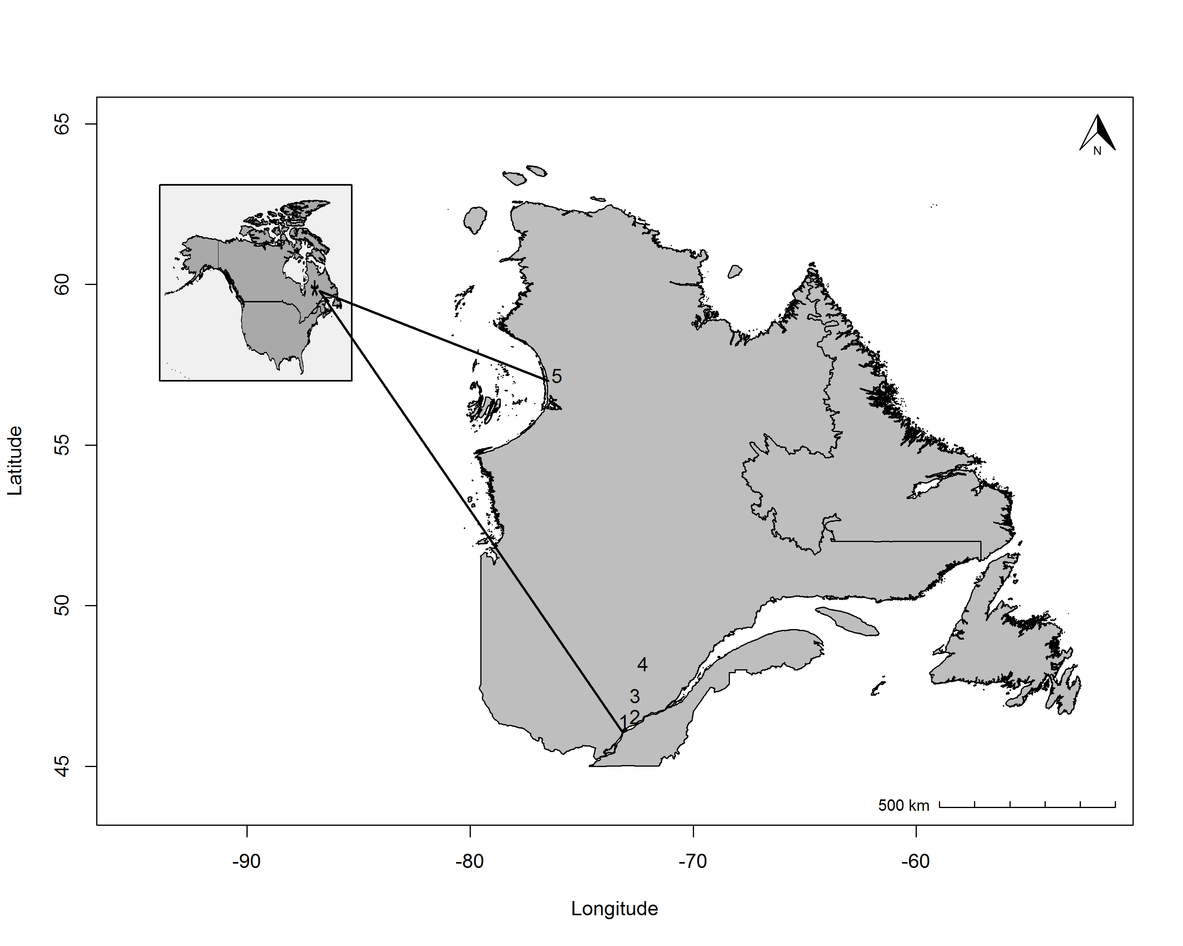
Figure 1. Latitudinal distribution of the five monitored ecosystems within the SAuVER network. 1- SCIRBI: Temperate wet meadows, 2- Maskinongé: Fluvial marshes 3- Ecological reserve of Lac-à-la-Tortue; Peatlands, 4- Ecological reserve of Bog-à-lanières; Peatlands, 5- Umiujaq; Arctic wet meadows.

Environmental context of each monitored ecosystem
Table 1. Climate and edaphic conditions characterizing each wetland. Ecosystem identity (Ecosystem), wetland type (Type), latitudinal location of the ecosystem (Latitude), mean annual temperature (Temperature), mean annual precipitation (Precipitation), soil and water pH (pH), soil moisture (Moisture). Climatic data were extracted from the databases maintained by the Minsitère du Développement Durable et de la Lutte aux Changements Climatiques during the period 1981 to 2010 (http://www.mddelcc.gouv.qc.ca/climat/normales/).
Edaphic conditions data were assessed during sampling period of August 2015. Mean pH and Moisture corresponds to the mean values of all measurement performed in each ecosystem which consist of four measures per plant communities in each ecosystem. In wet meadows and marshes, soil pH was measured in the lab from soil sample collected in the field using a 1:8 (v/v) soil:water solution. Samples were analyzed no later than one week after sampling. In ombrotrophic bogs, water pH was measured directly in the field. All pH measurements were taken using pH probe HI98121 (Hanna instrument, Smithfield, RI, USA). Soil moisture was assessed using WetSensor device (Delta-T Devices Ltd, Cambridge, UK) directly in the field. Within each ecosystem, field measurements were done within the same day.
Ecosystem | Type | Latitude (°DD.dd) | Temperature  (Mean; °C) | Precipitation  (Mean; mm) |  | pH (Mean±Sd) | Moisture (%)  (Mean±Sd)
SCIRBI | Riparian buffers | 46.07 | 6.40 | 997.2 | 5.48 ± 0.26 |  | 39.42 ± 13.69
Maskinonge | Fluvial marshes | 46.19 | 5.10 | 1009.3 | 6.36 ± 0.28 |  | 54.53 ± 15.47
Lac-à-la-Tortue | Ombrotrophic bog | 46.55 | 4.80 | 1085.0 | 3.47 ± 0.11 |  | 77.71 ± 11.14
Bog-à-lanières | Ombrotrophic bog | 47.59 | 2.00 | 1016.4 | 4.01 ± 0.11 |  | 59.56 ± 12.93
Umiujaq | Arctic wet meadows | 56.57 | -4.60 | 660.8 | 5.38 ± 0.38 |  | 58.40 ± 20.03

Edaphic conditions relationship with species richness
Within year 2015, plant communities among the same ecosystem were similar in terms of soil and water pH but a gradient of soil moisture was observed within each ecosystem. However, our analysis revealed that the species richness gradient among communities selected in each ecosystem was independent of these edaphic conditions. Indeed, no clear relationship was observed between these conditions and species richness (alpha diversity) in each ecosystem (Figure 2).

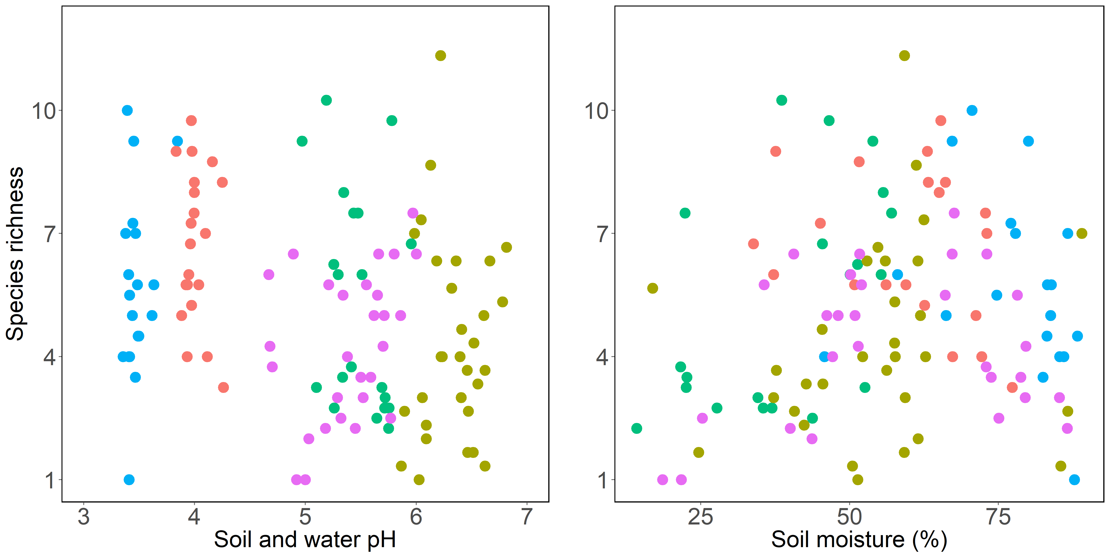
Figure 2. Edaphic conditions relationship with species richness within each ecosystem. pH (Left panel) and Soil moisture (Right panel) relationships with species richness (alpha diversity). 1- SCIRBI (Green), 2- Maskinongé (Brown), 3- Lac-à-la-Tortue(Red), 4- Bog-à-lanières (Blue), 5- Umiujaq (Purple).

Edaphic condition relationship with growing season phenology within wetlands
Edaphic conditions observed in 2015 did not explained more than 10% of growing season variability thus suggesting that edaphic conditions measured did not play an important role in the regulation of plant communities’ phenology and its spatial variability within ecosystems in 2015 (Table 2). Assuming that the edaphic conditions gradient did not change significantly in terms of pH and soil moisture during previous and subsequent years, we considered that it did not play a significant role in the phenological heterogeneity observed within each ecosystem during the whole experiment.
Table 2. Contribution of soil pH, soil moisture and their interactions (fixed effect; Marginal R²) and the ecosystem identity (random effect on the intercept of each phenophases; Conditional R²) to green-up date (Green-up), green-down date (Green-down) and growing season length (Length) in 2015.
Phenophases | Marginal R² | Conditional R²
Green-up | 0.03 | 0.93
Green-down | 0.10 | 0.52
Length | 0.08 | 0.85

Table 3. Number of time series analysed for green-up and green down dates and growing season length per year.
Years | Green-up | Green-down | Growing season length
2013 | 54 | 53 | 50
2014 | 81 | 67 | 63
2015 | 76 | 107 | 78
2016 | 103 | 97 | 95
All years | 306 | 324 | 286

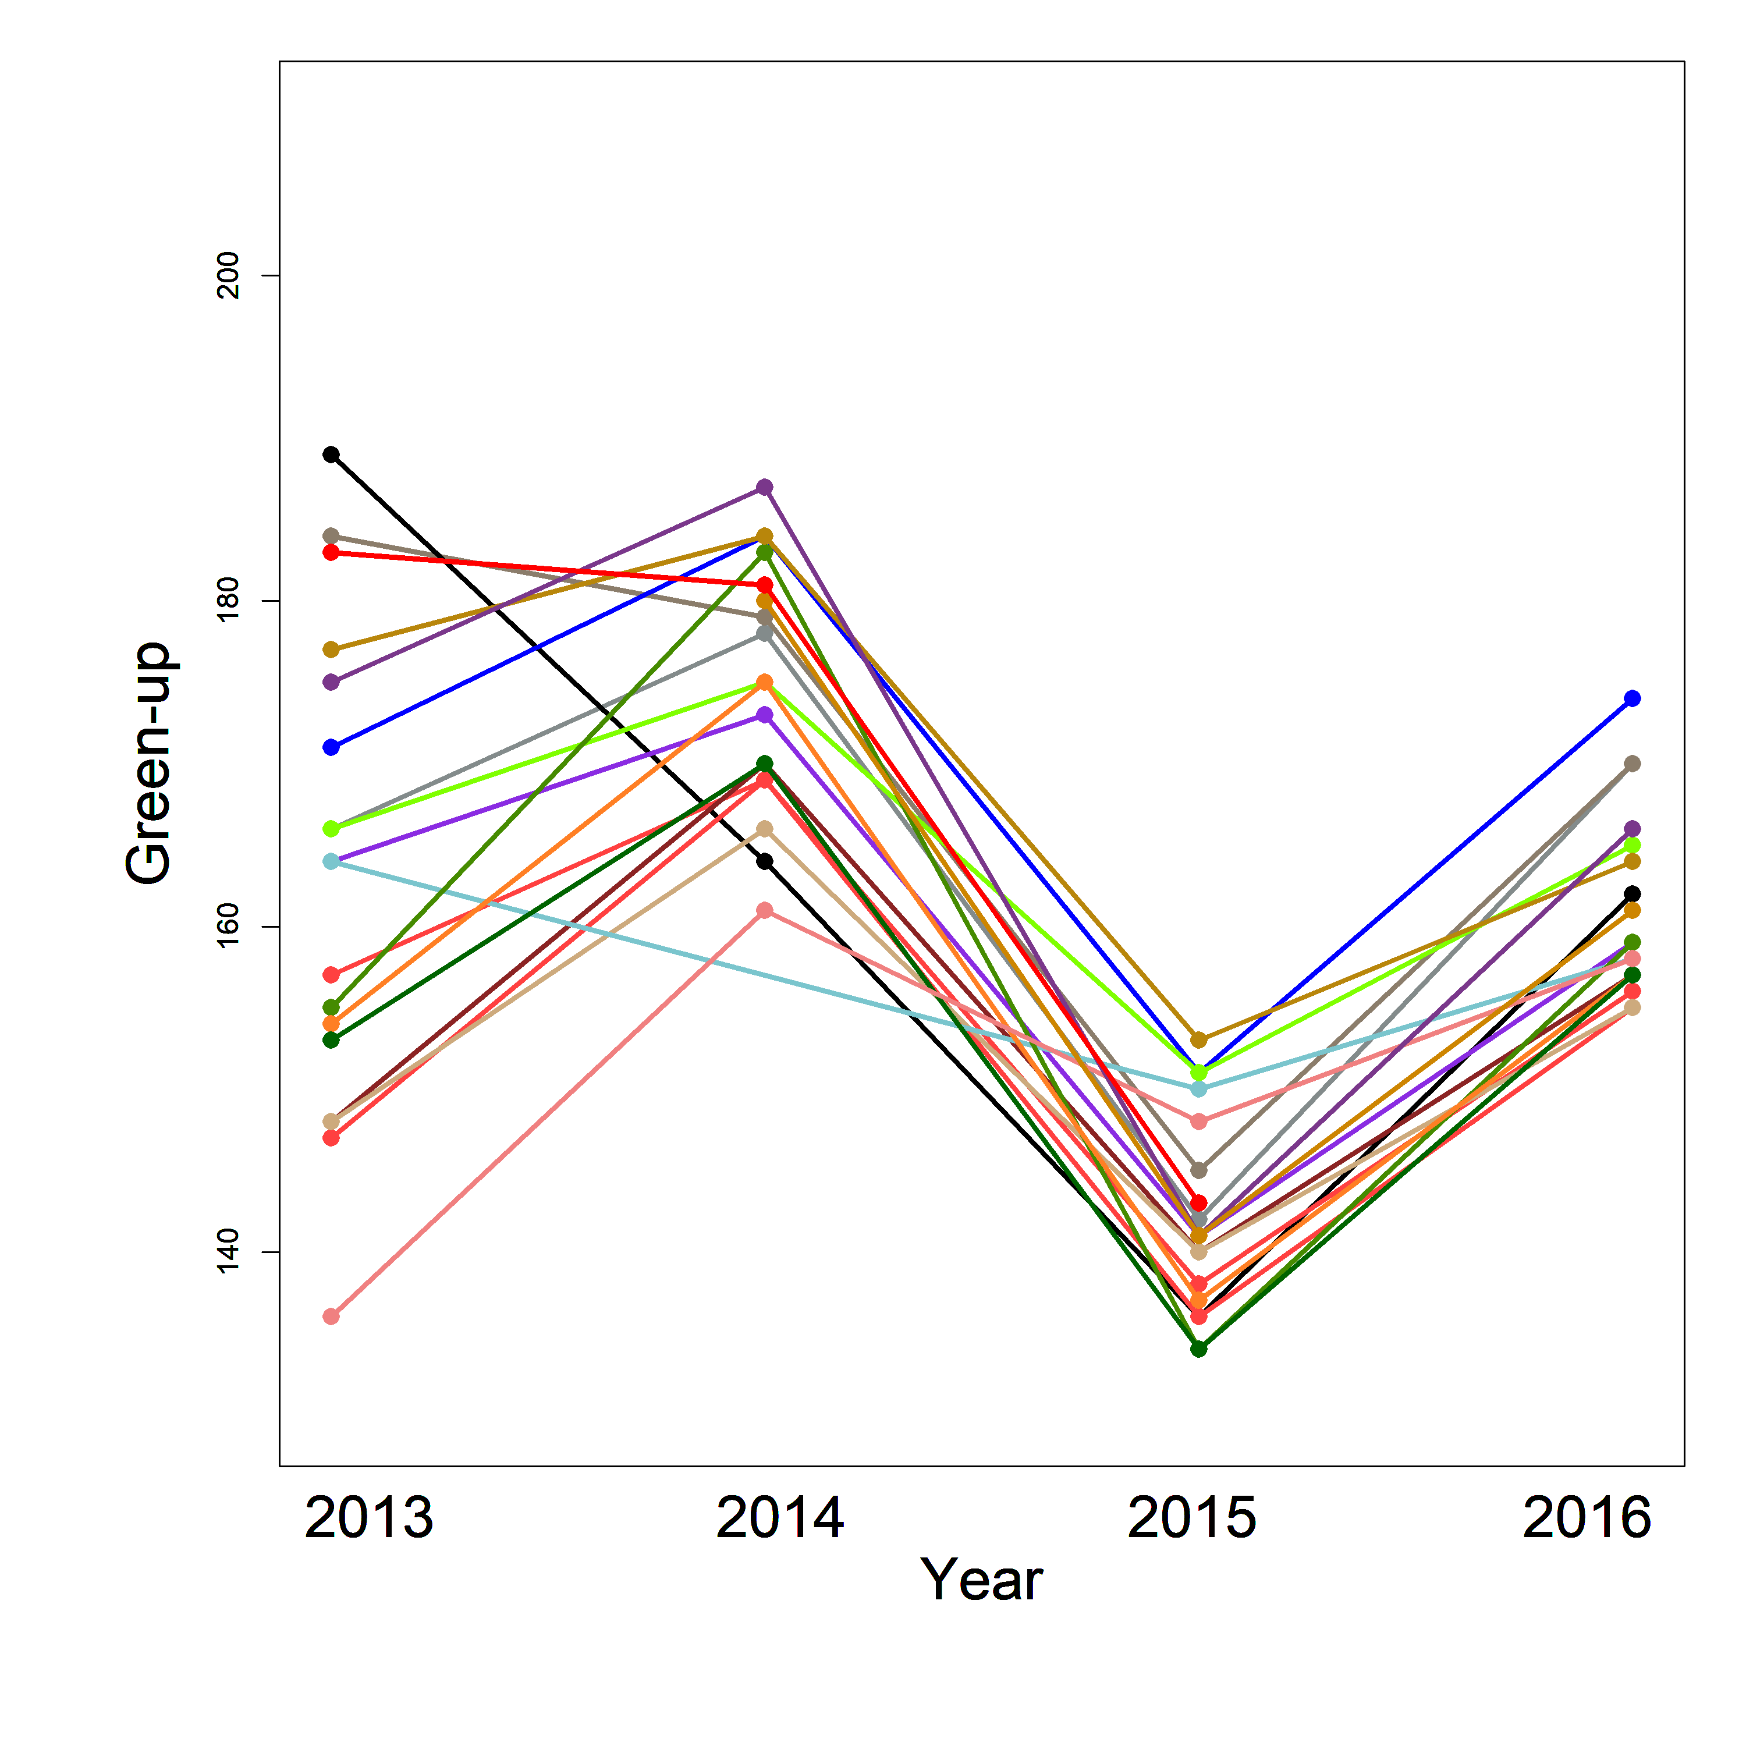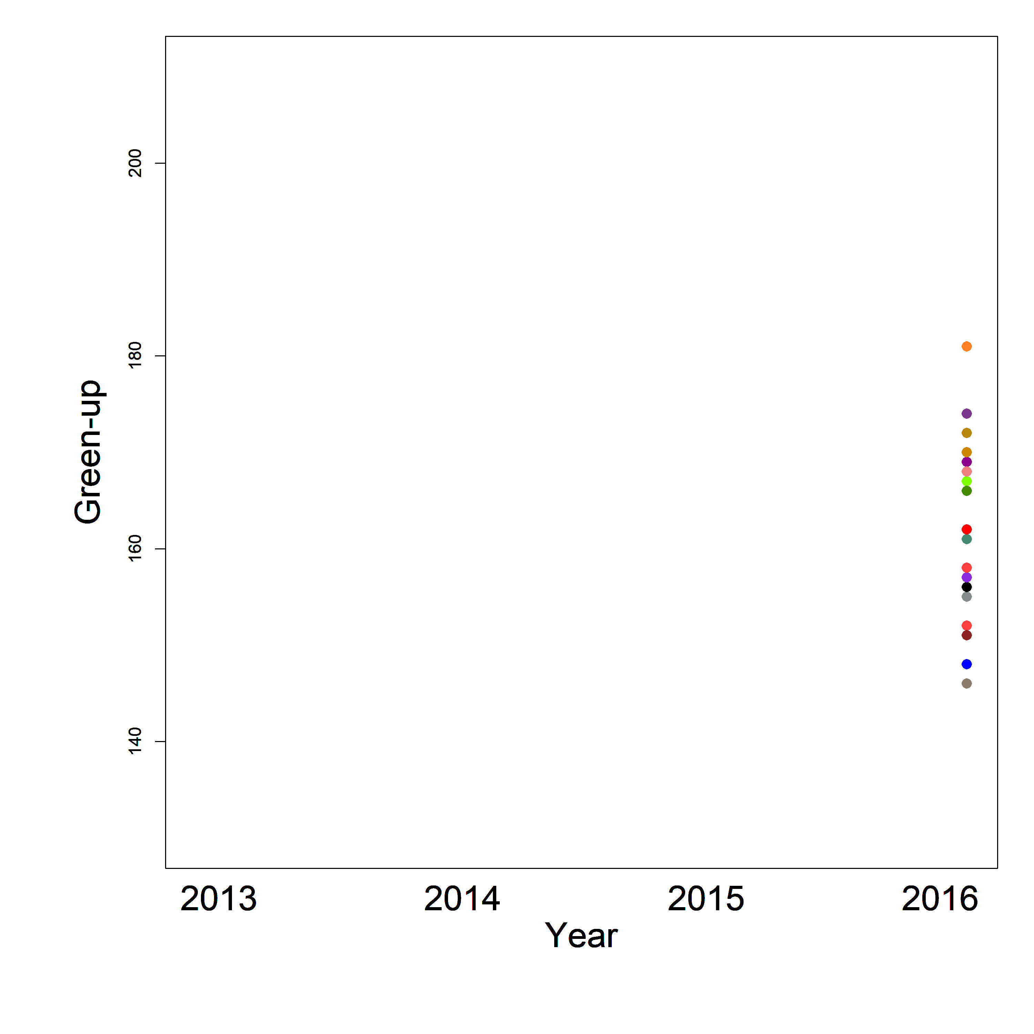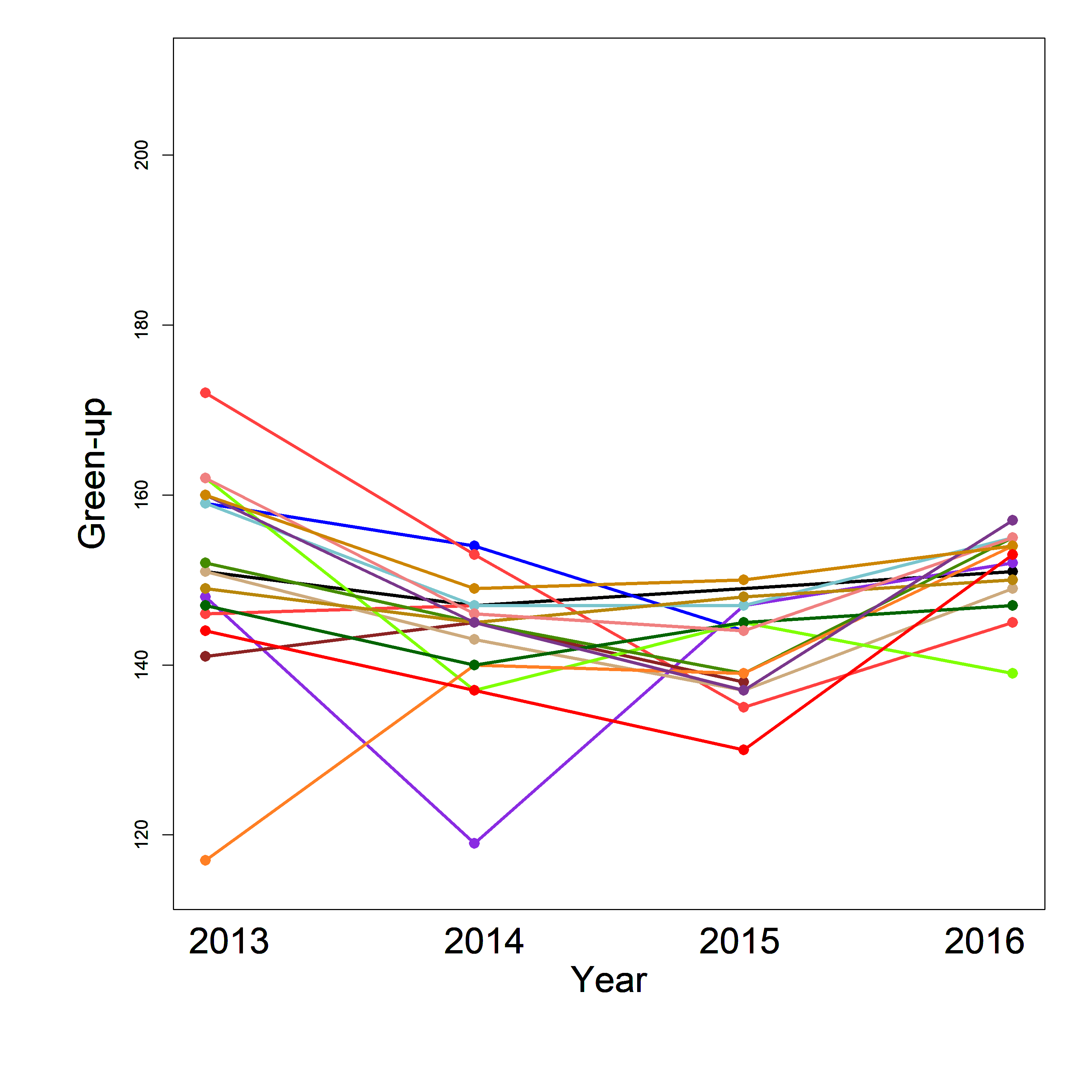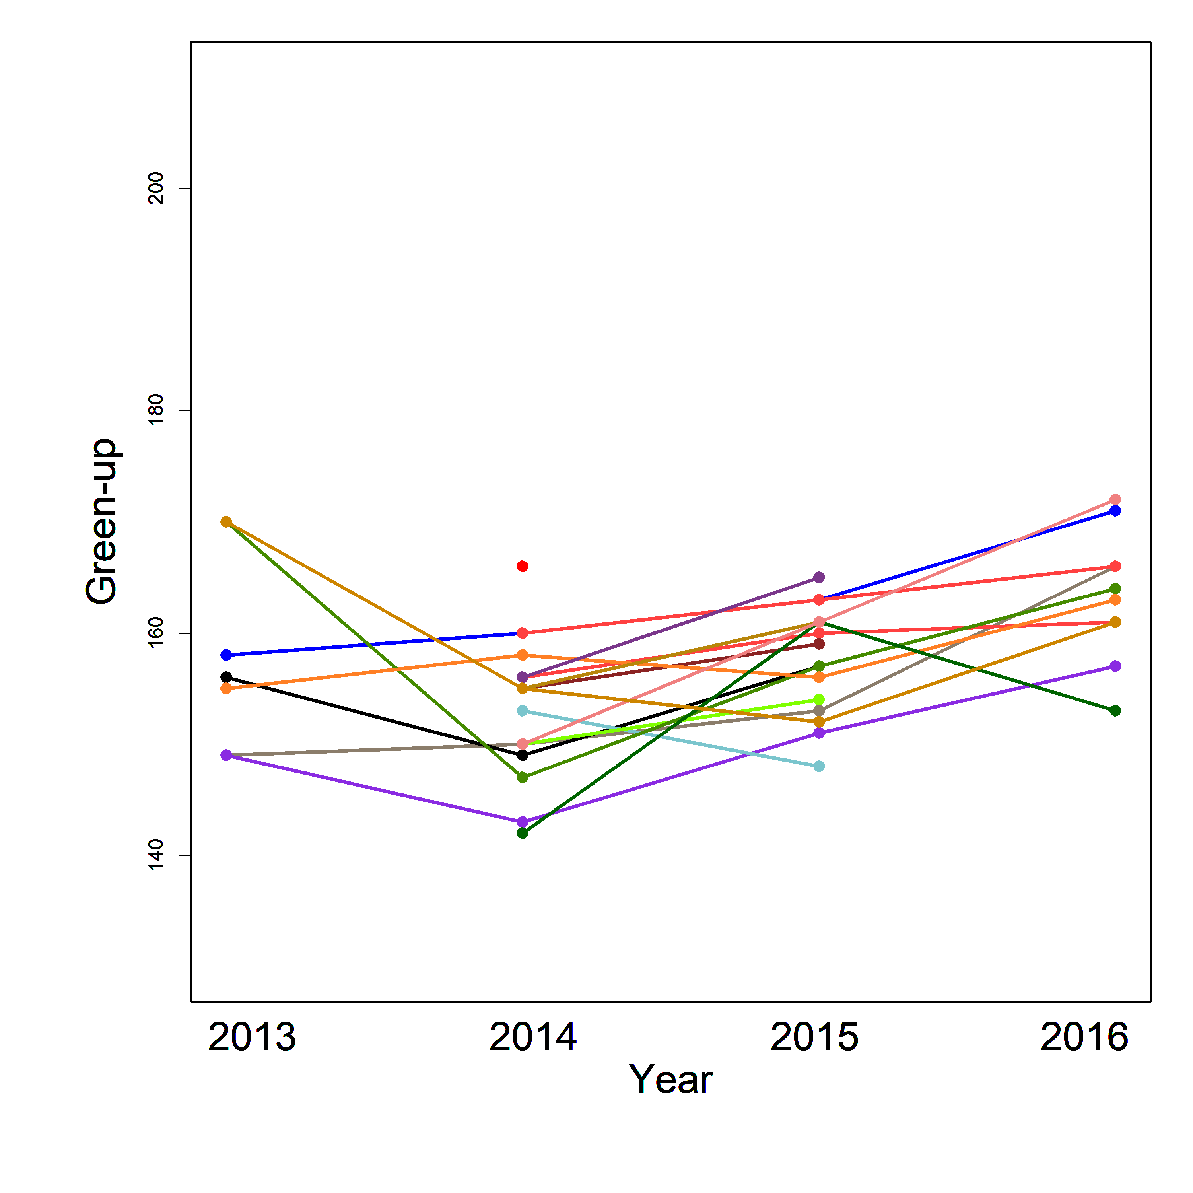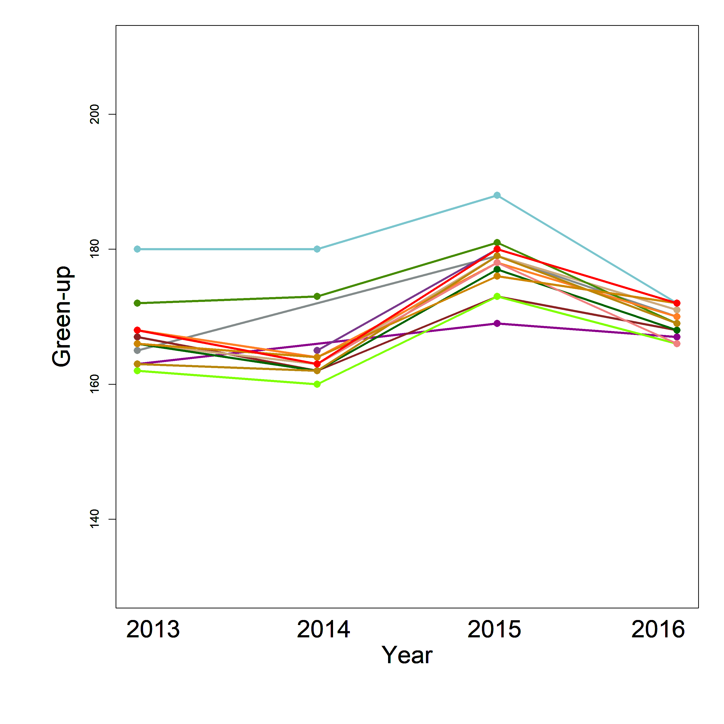
Figure 3. Interannual trend of the green-up of the growing season of 1) Temperate wet meadows (SCIRBI), 2) fluvial marshes (Maskinongé), 3)Peatlands (Lac-à-la-Tortue), 4) Peatlands (Bog-à-lanières) and 5) Arctic wet meadows (Umiujaq). Each color represents a unique plant community within each ecosystem(dots). Dots represents onset of a particular community in a given year and lines represent interannual trends of the green-up for each community.
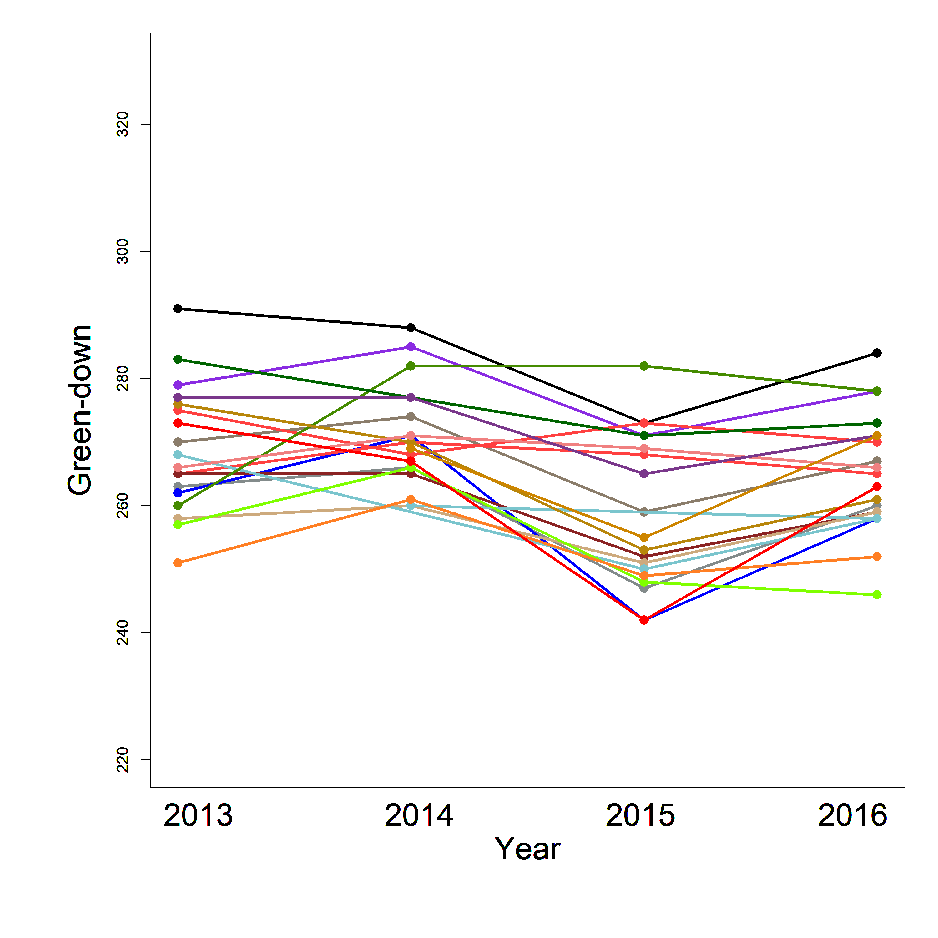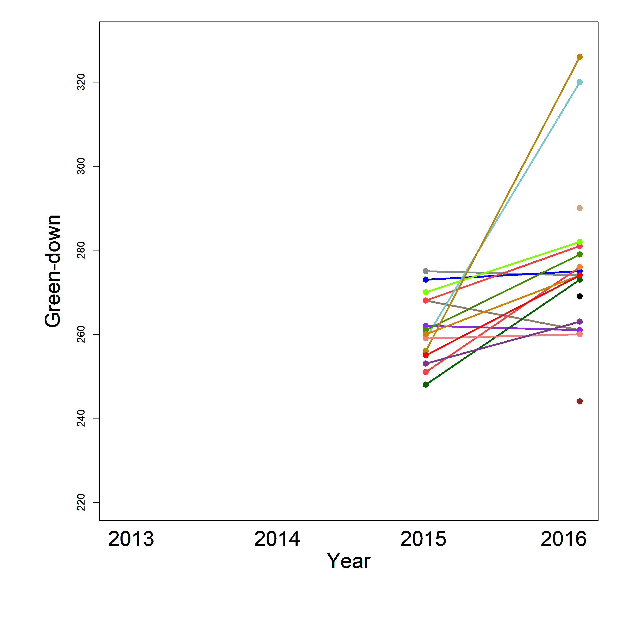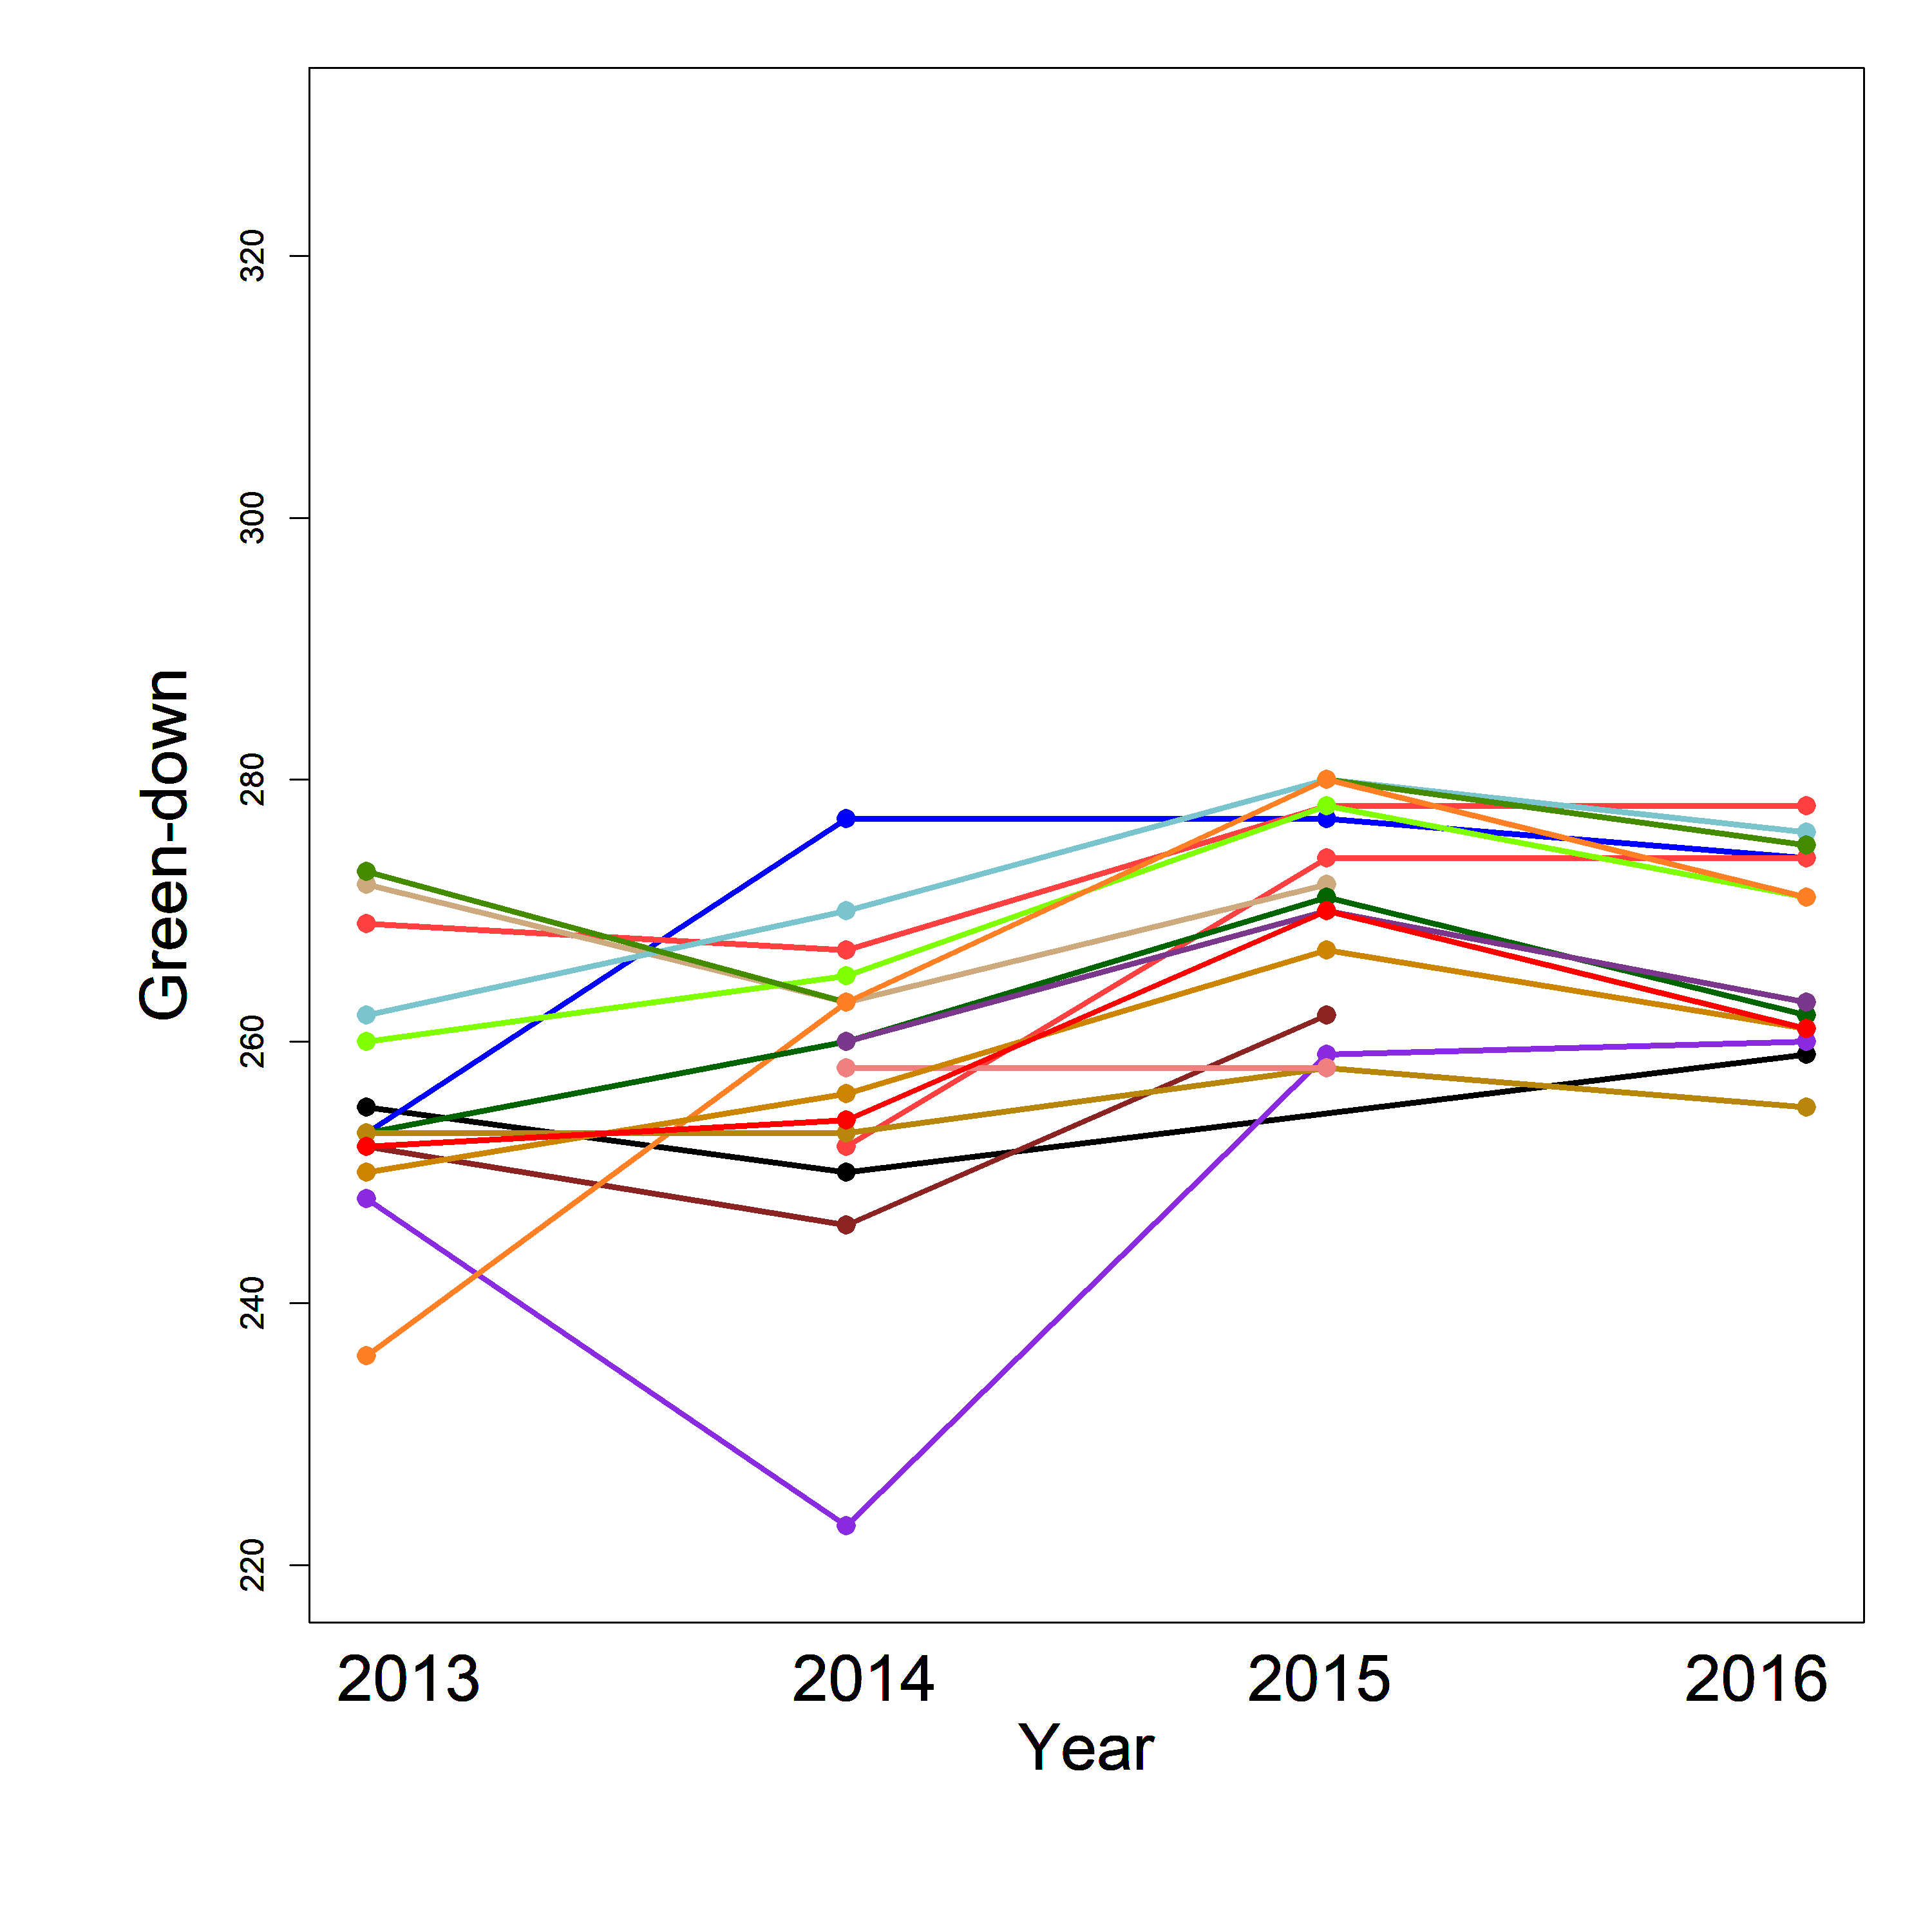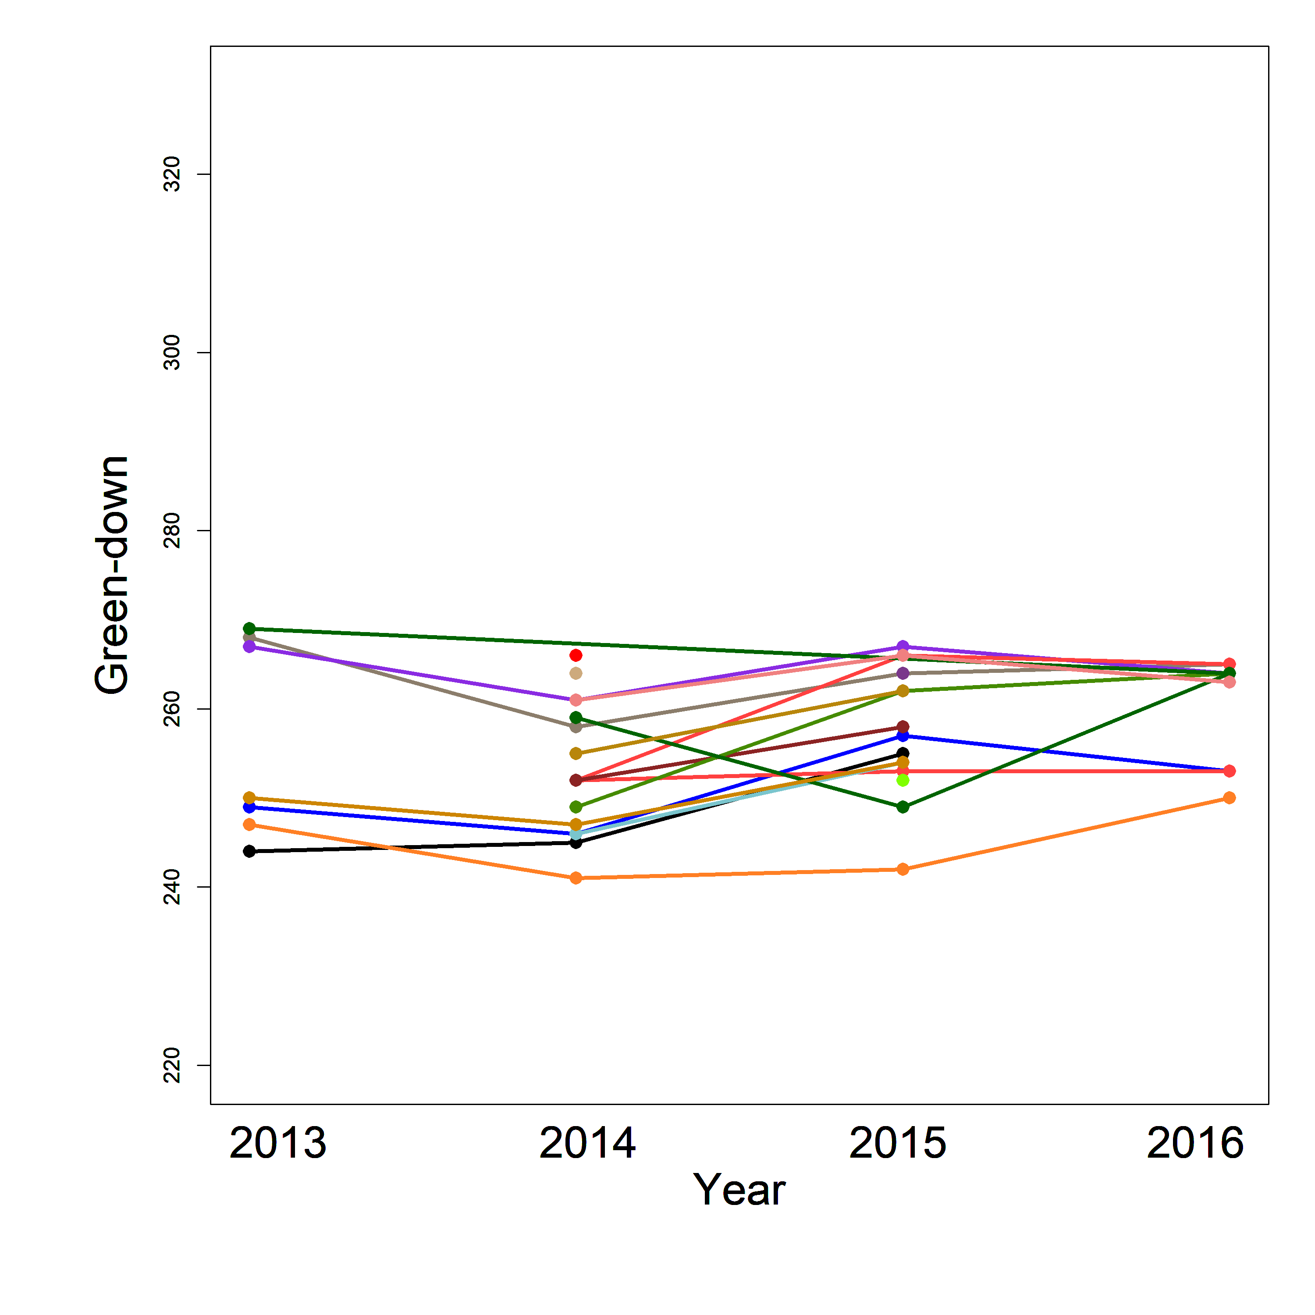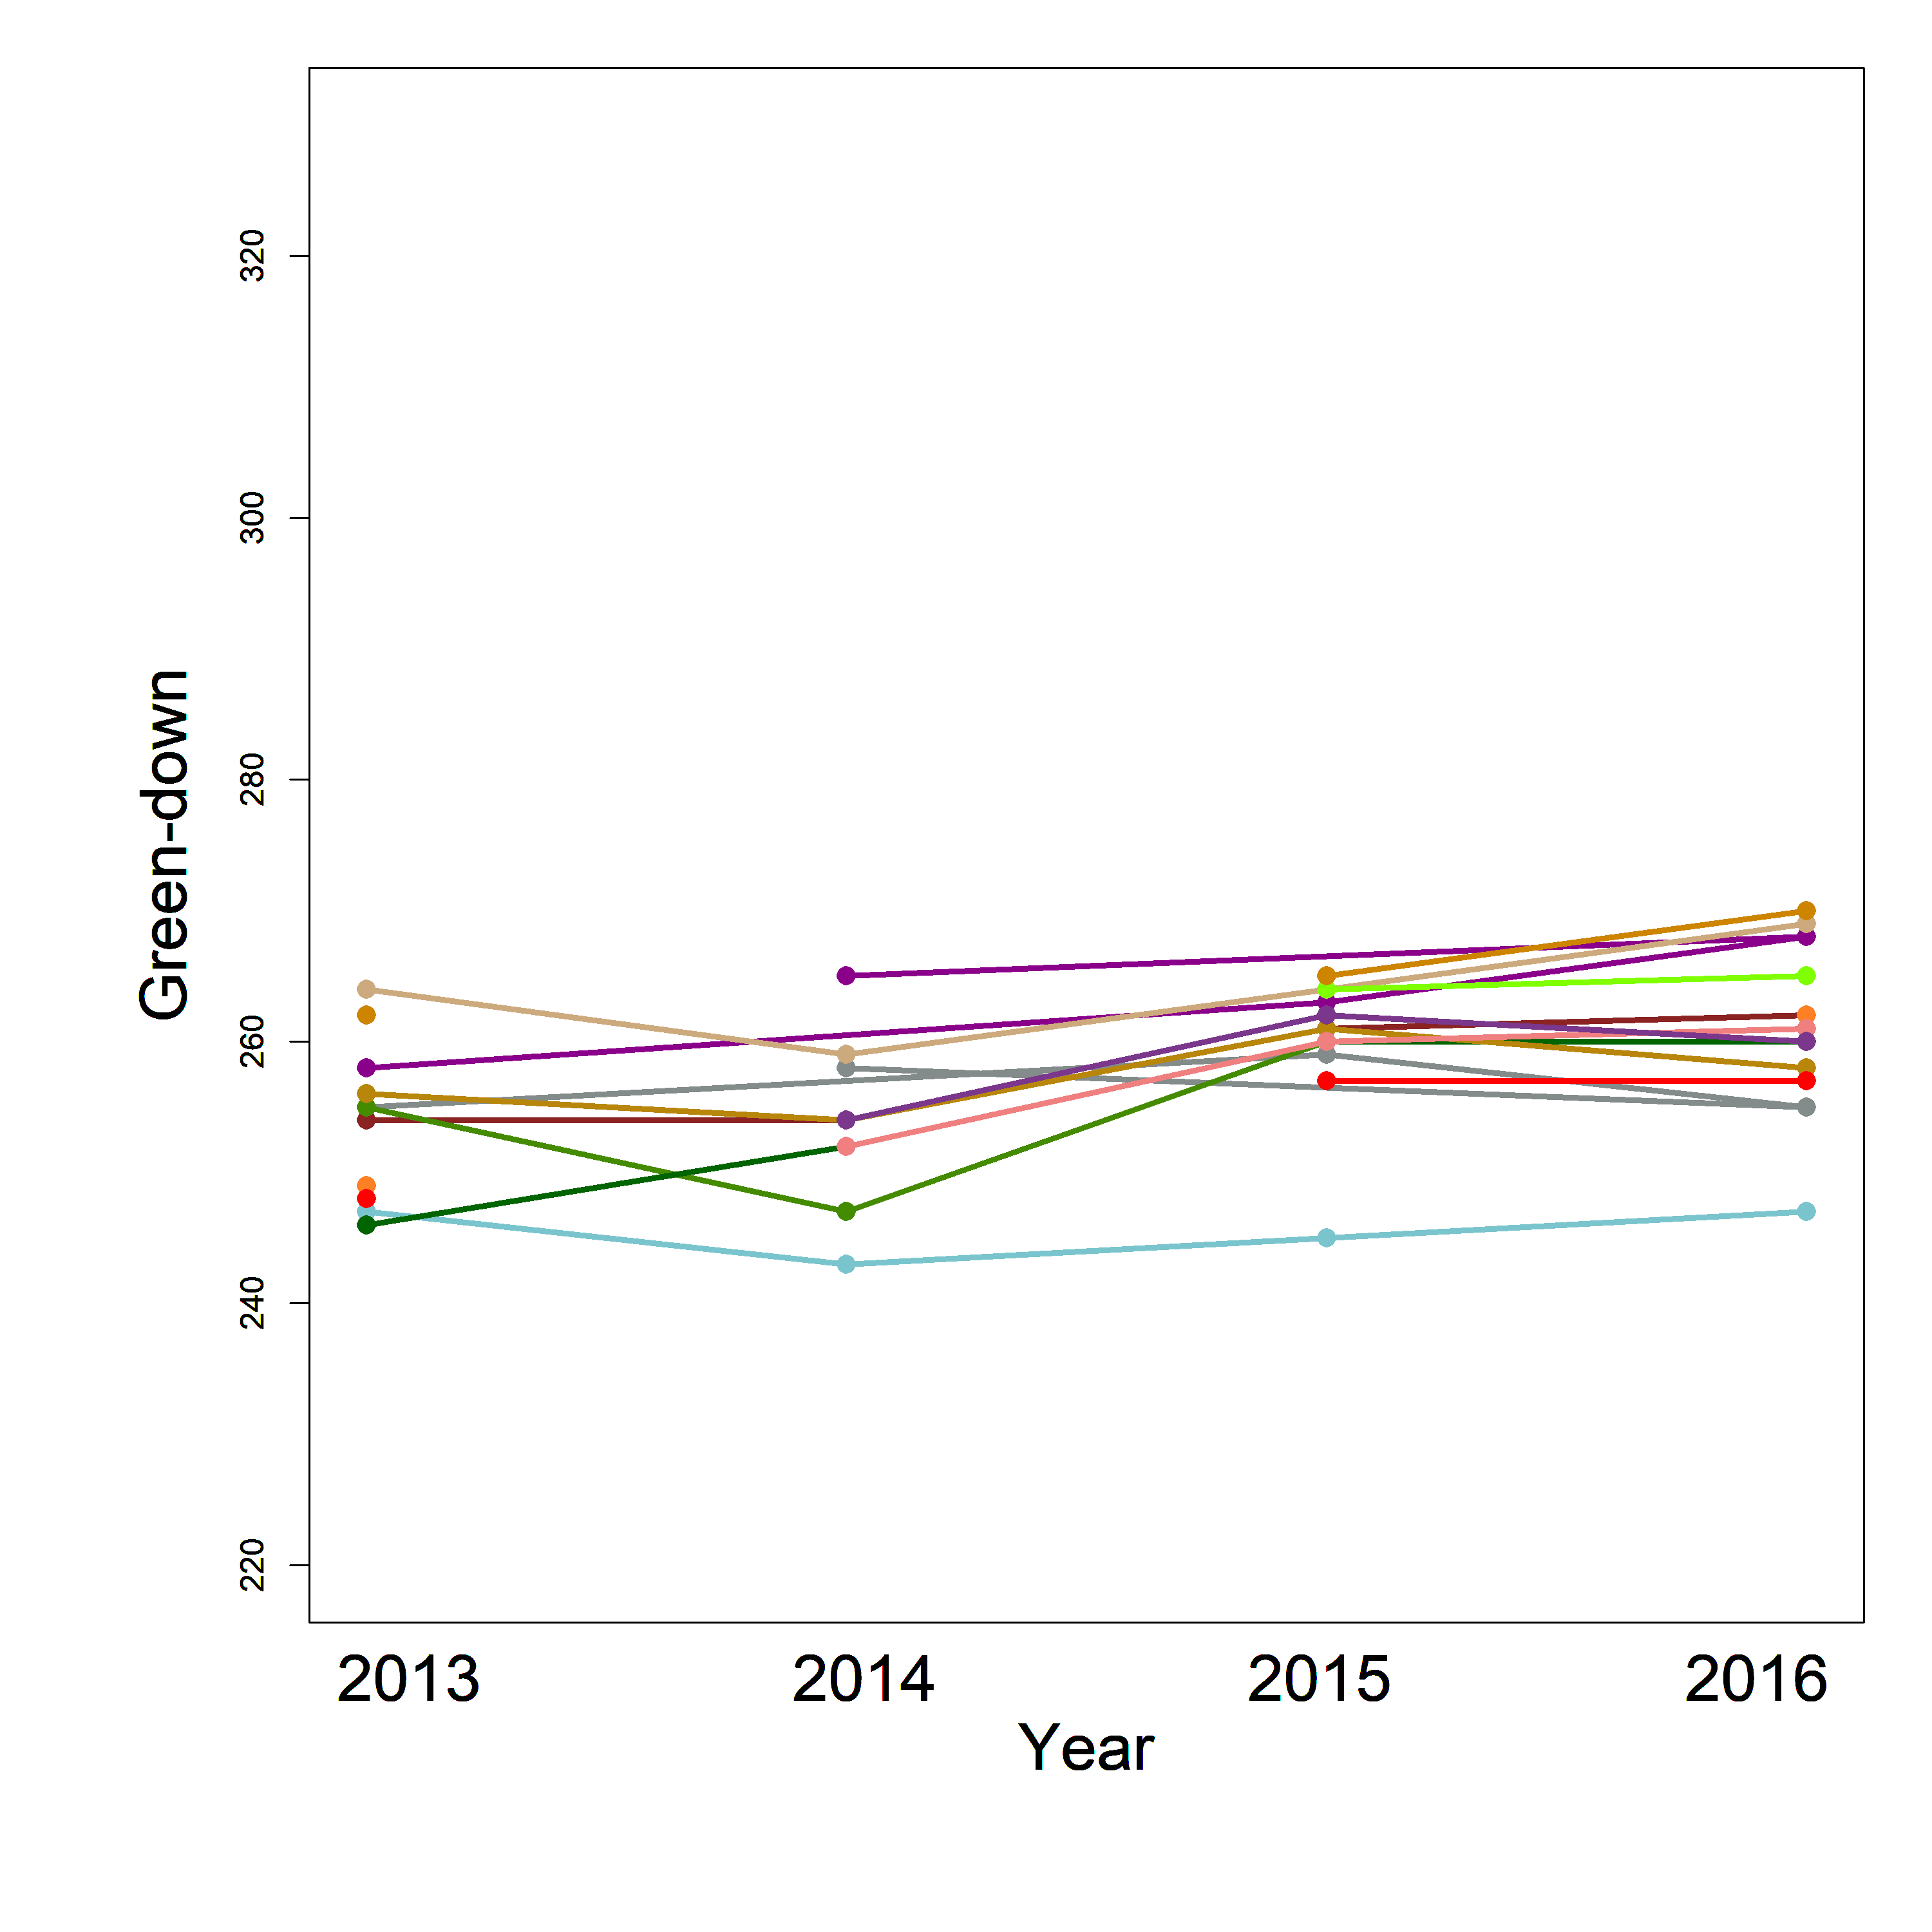
A)
A)
Figure 4. Interannual trend of the green-down of the growing season of 1) Temperate wet meadows (SCIRBI), 2) fluvial marshes (Maskinongé), 3)Peatlands (Lac-à-la-Tortue), 4) Peatlands (Bog-à-lanières) and 5) Arctic wet meadows (Umiujaq). Each color represents a unique plant community within each ecosystem(dots). Dots represents offset of a particular community in a given year and lines represent interannual trends of the green-down for each community.
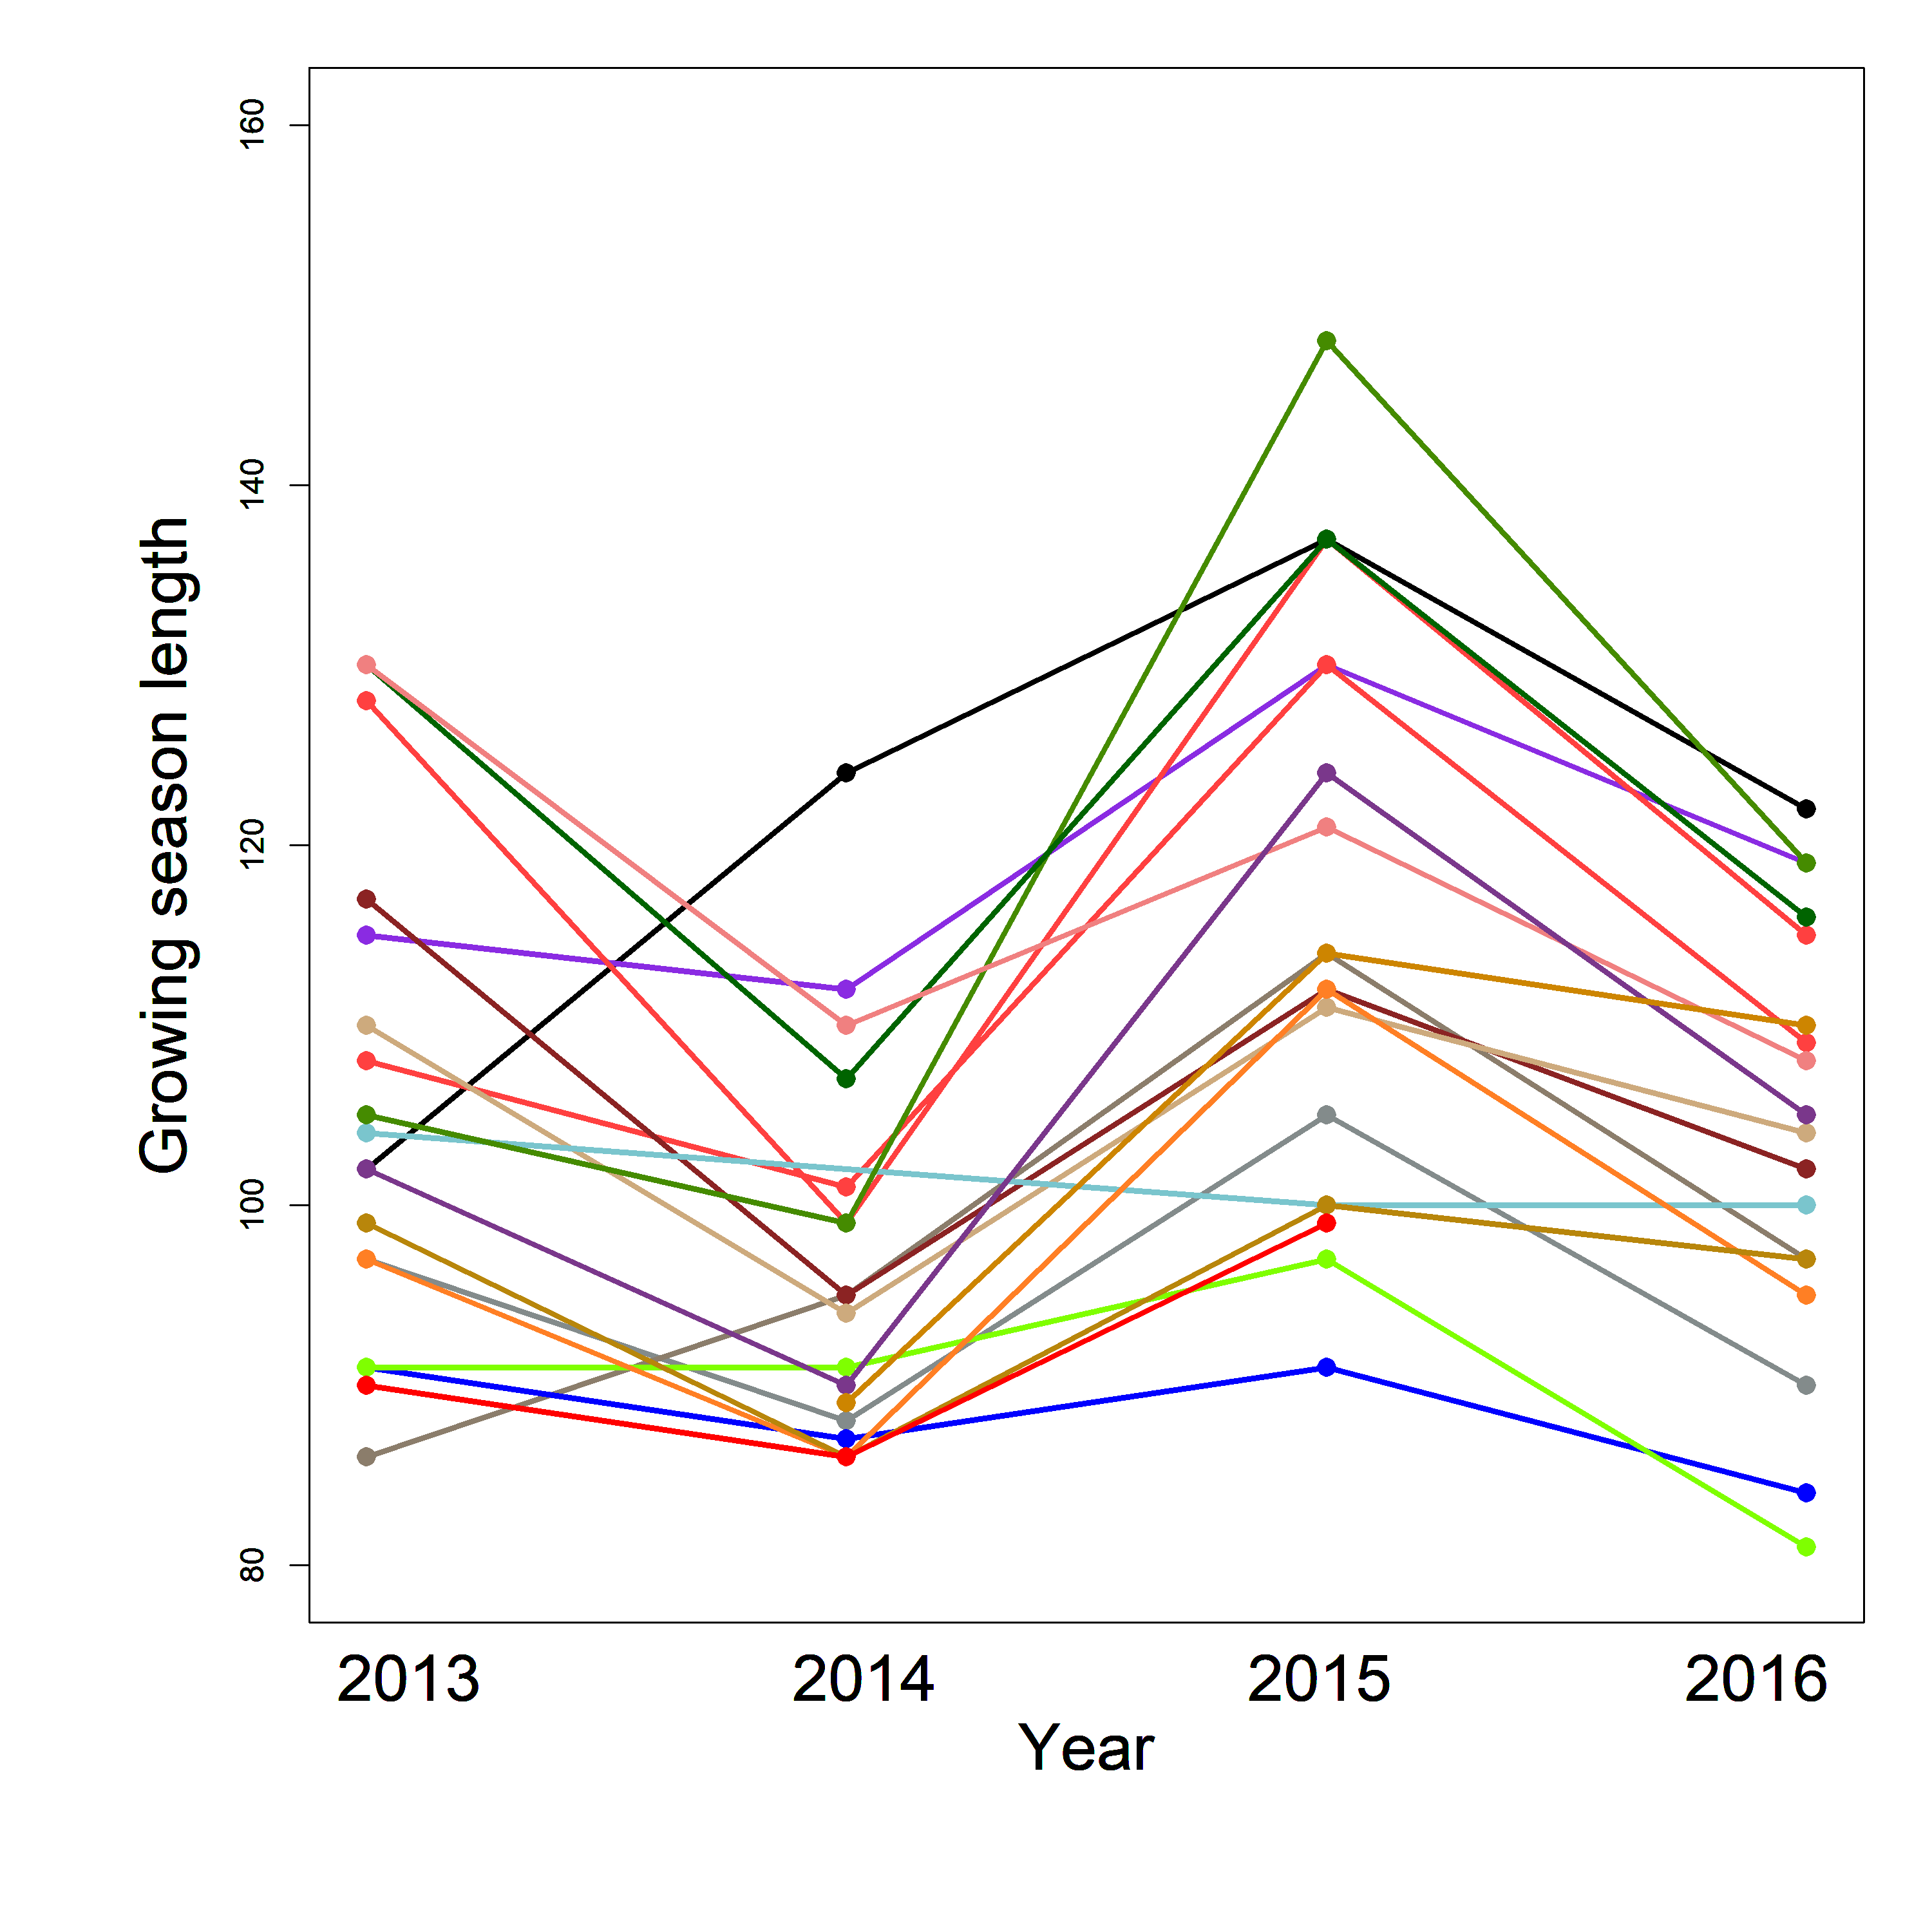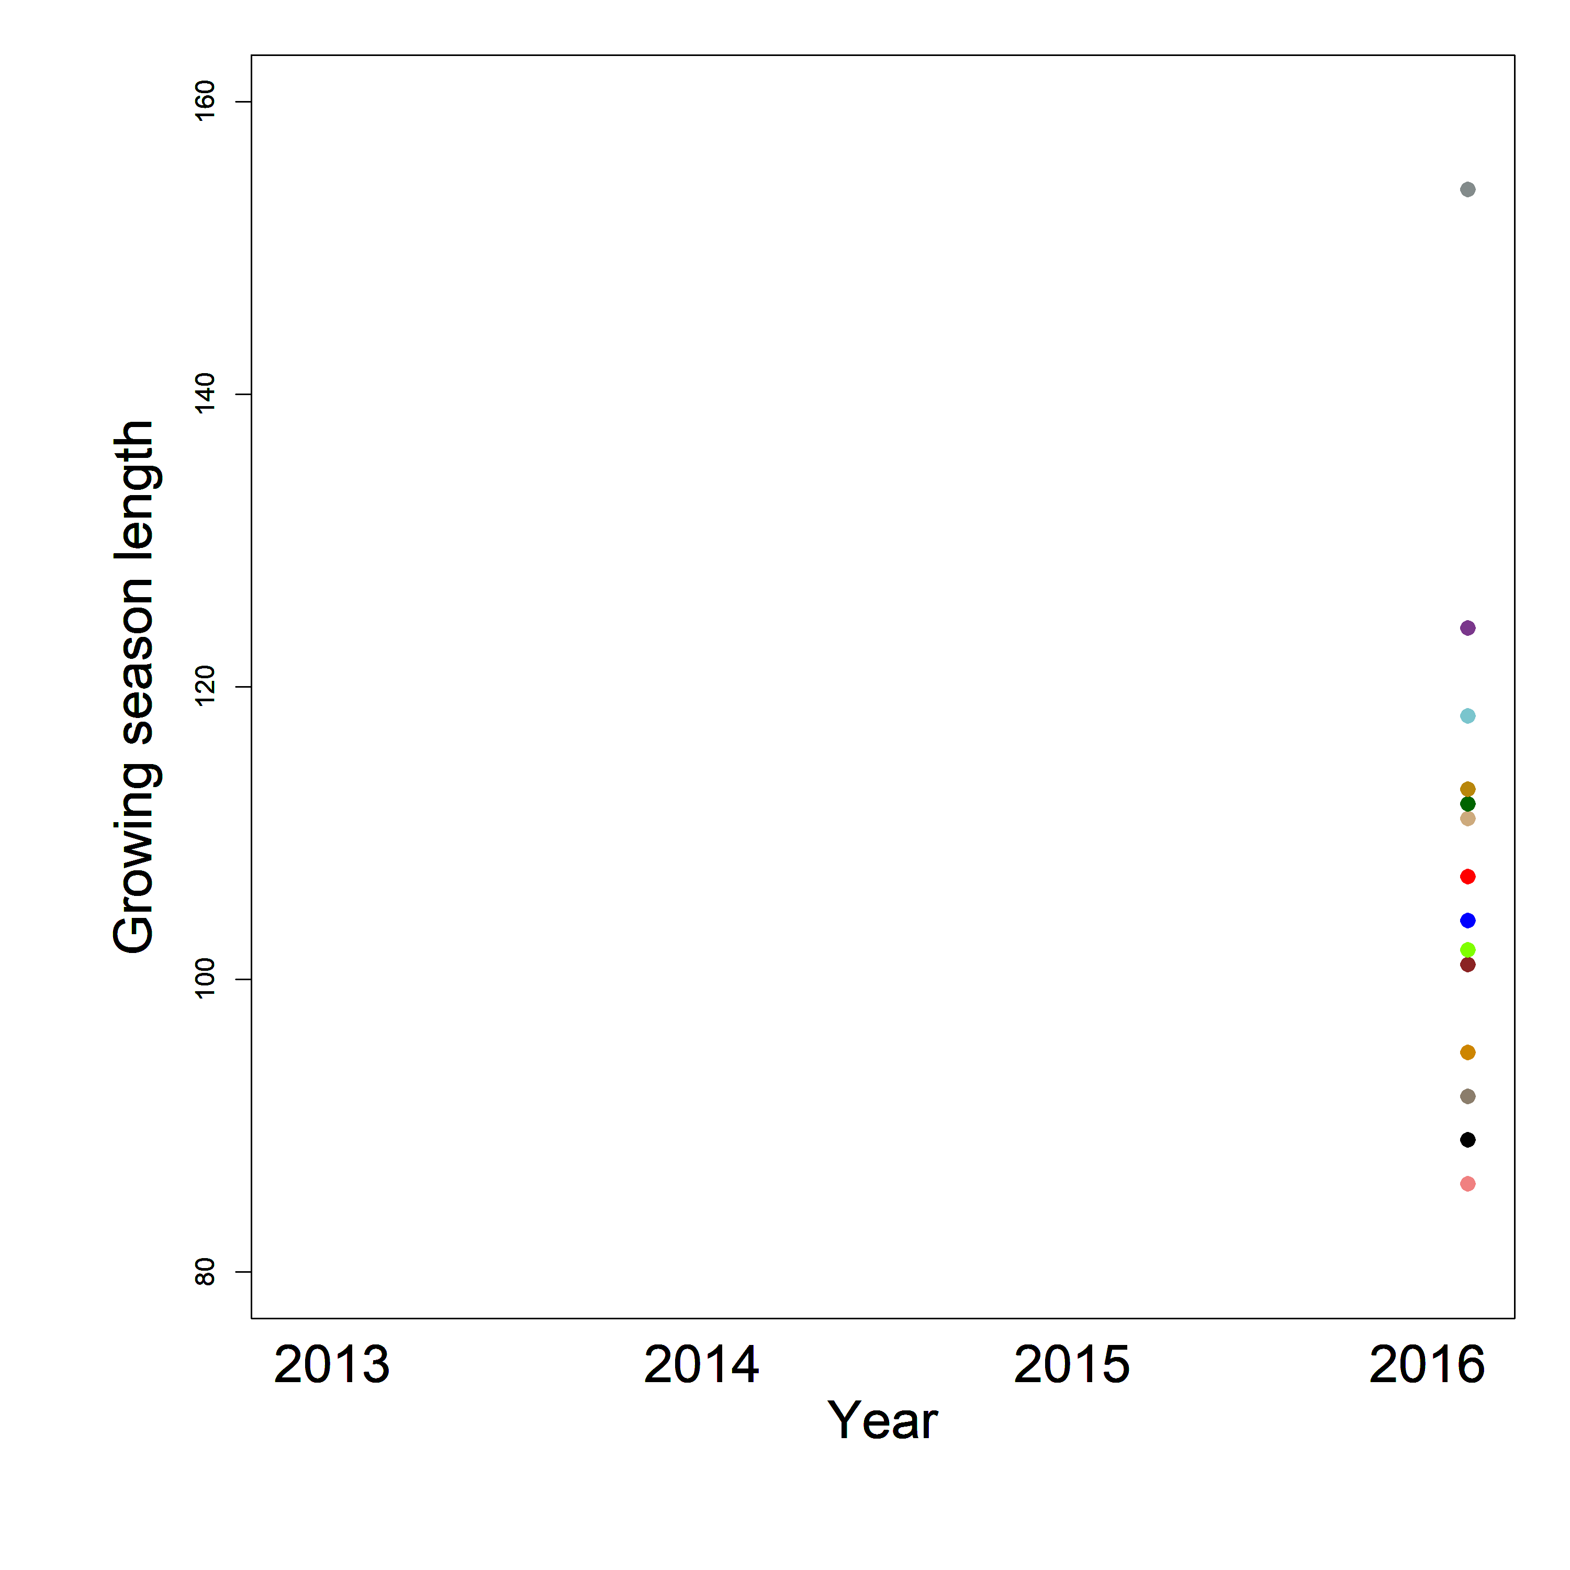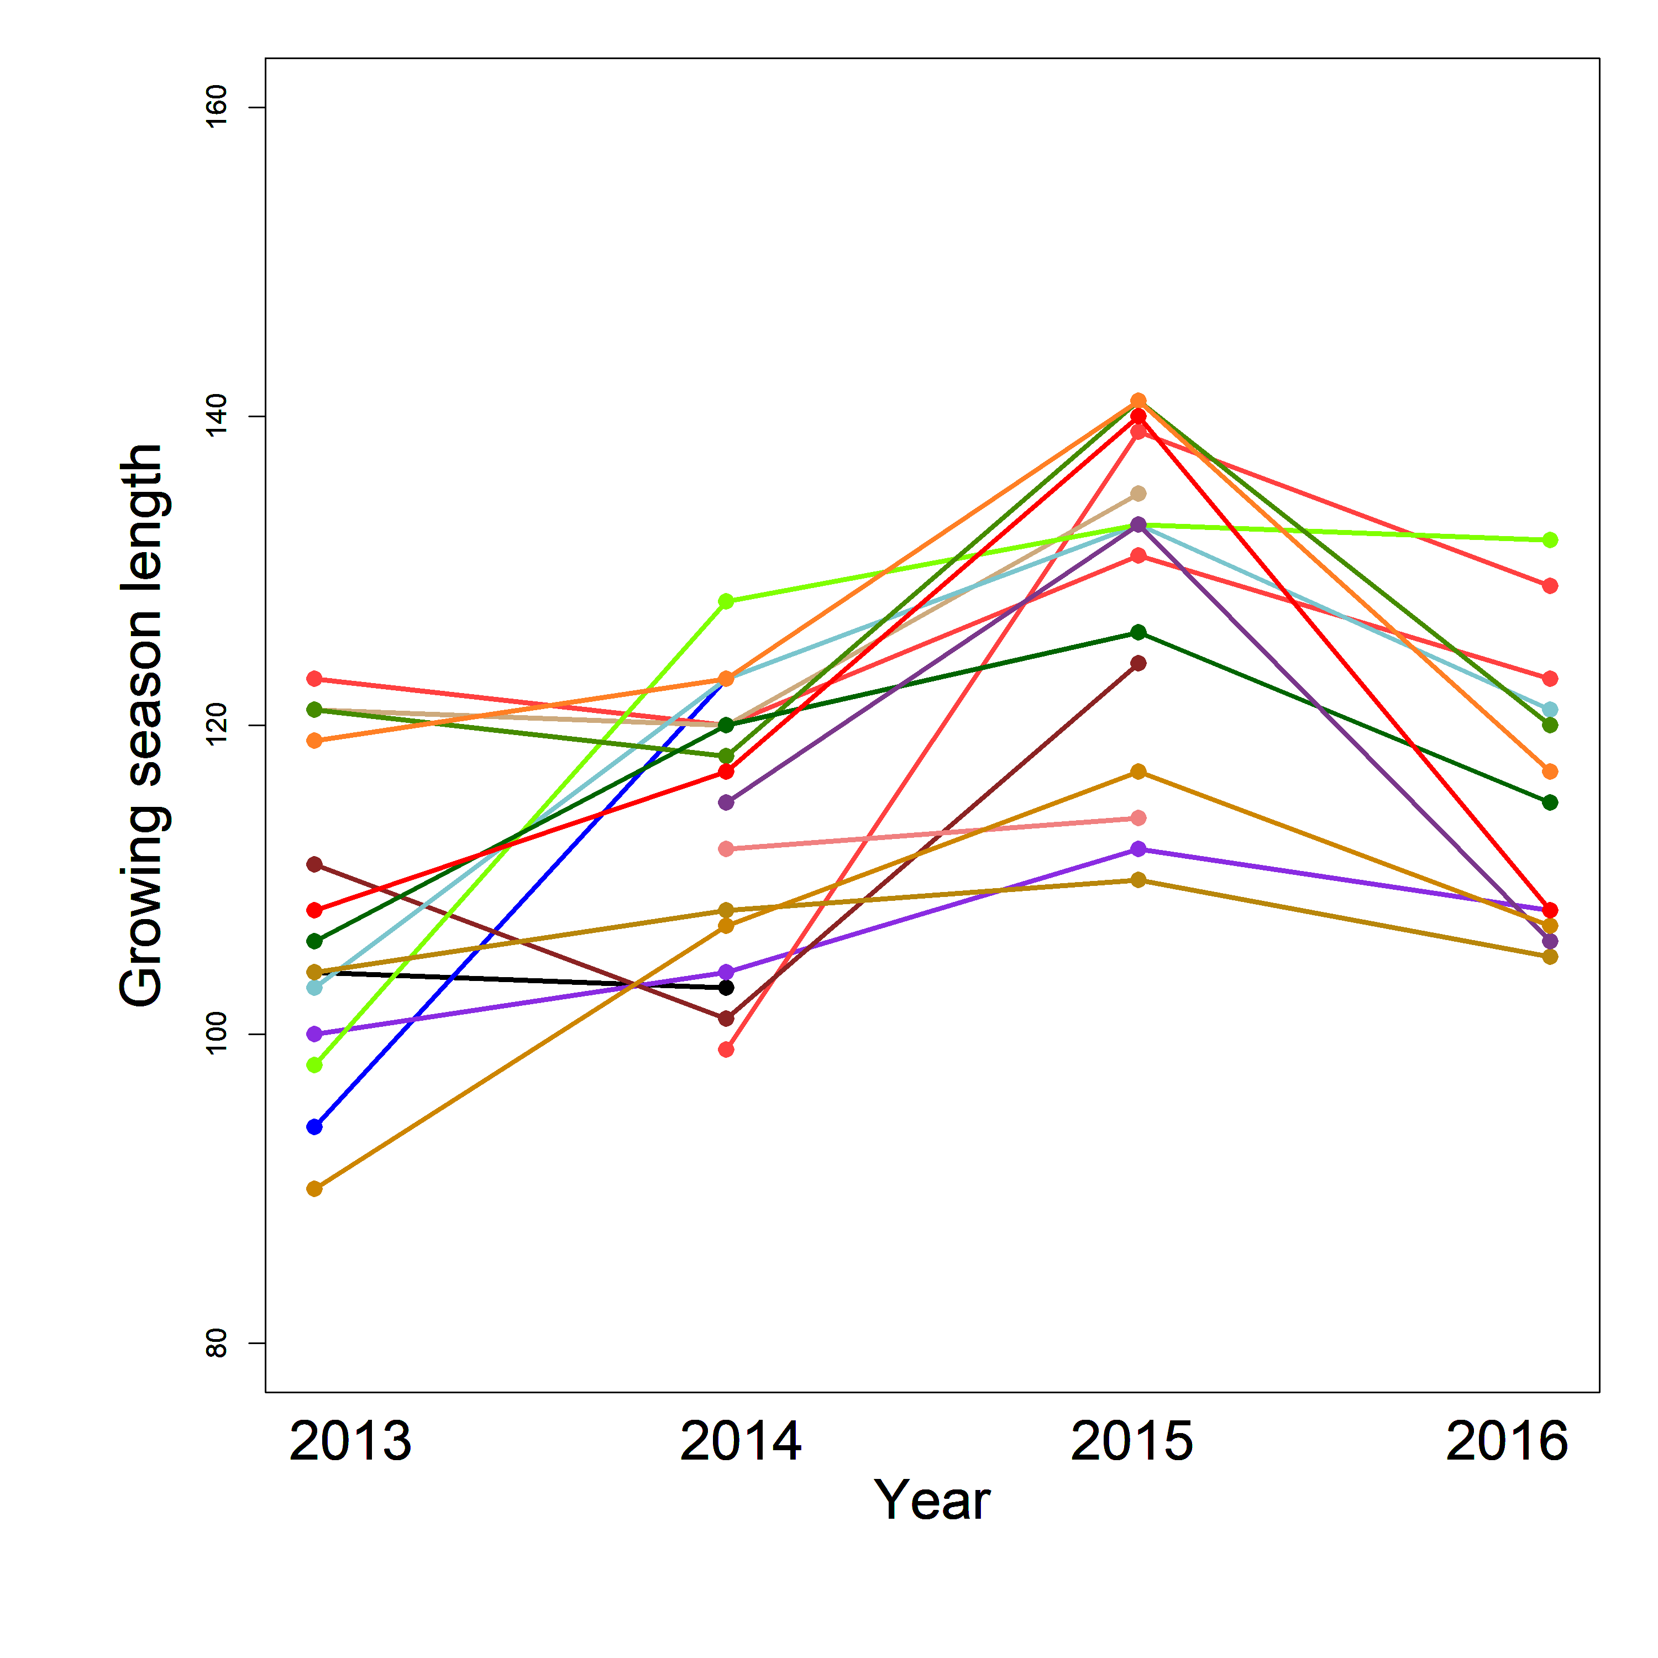
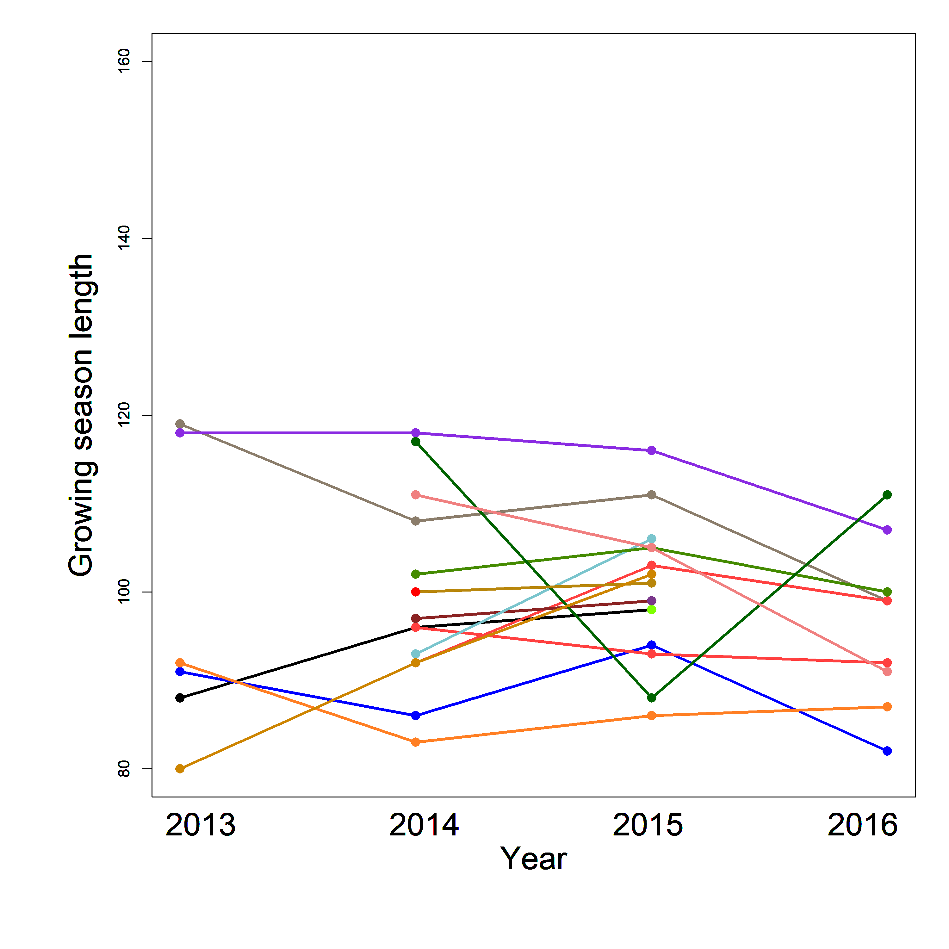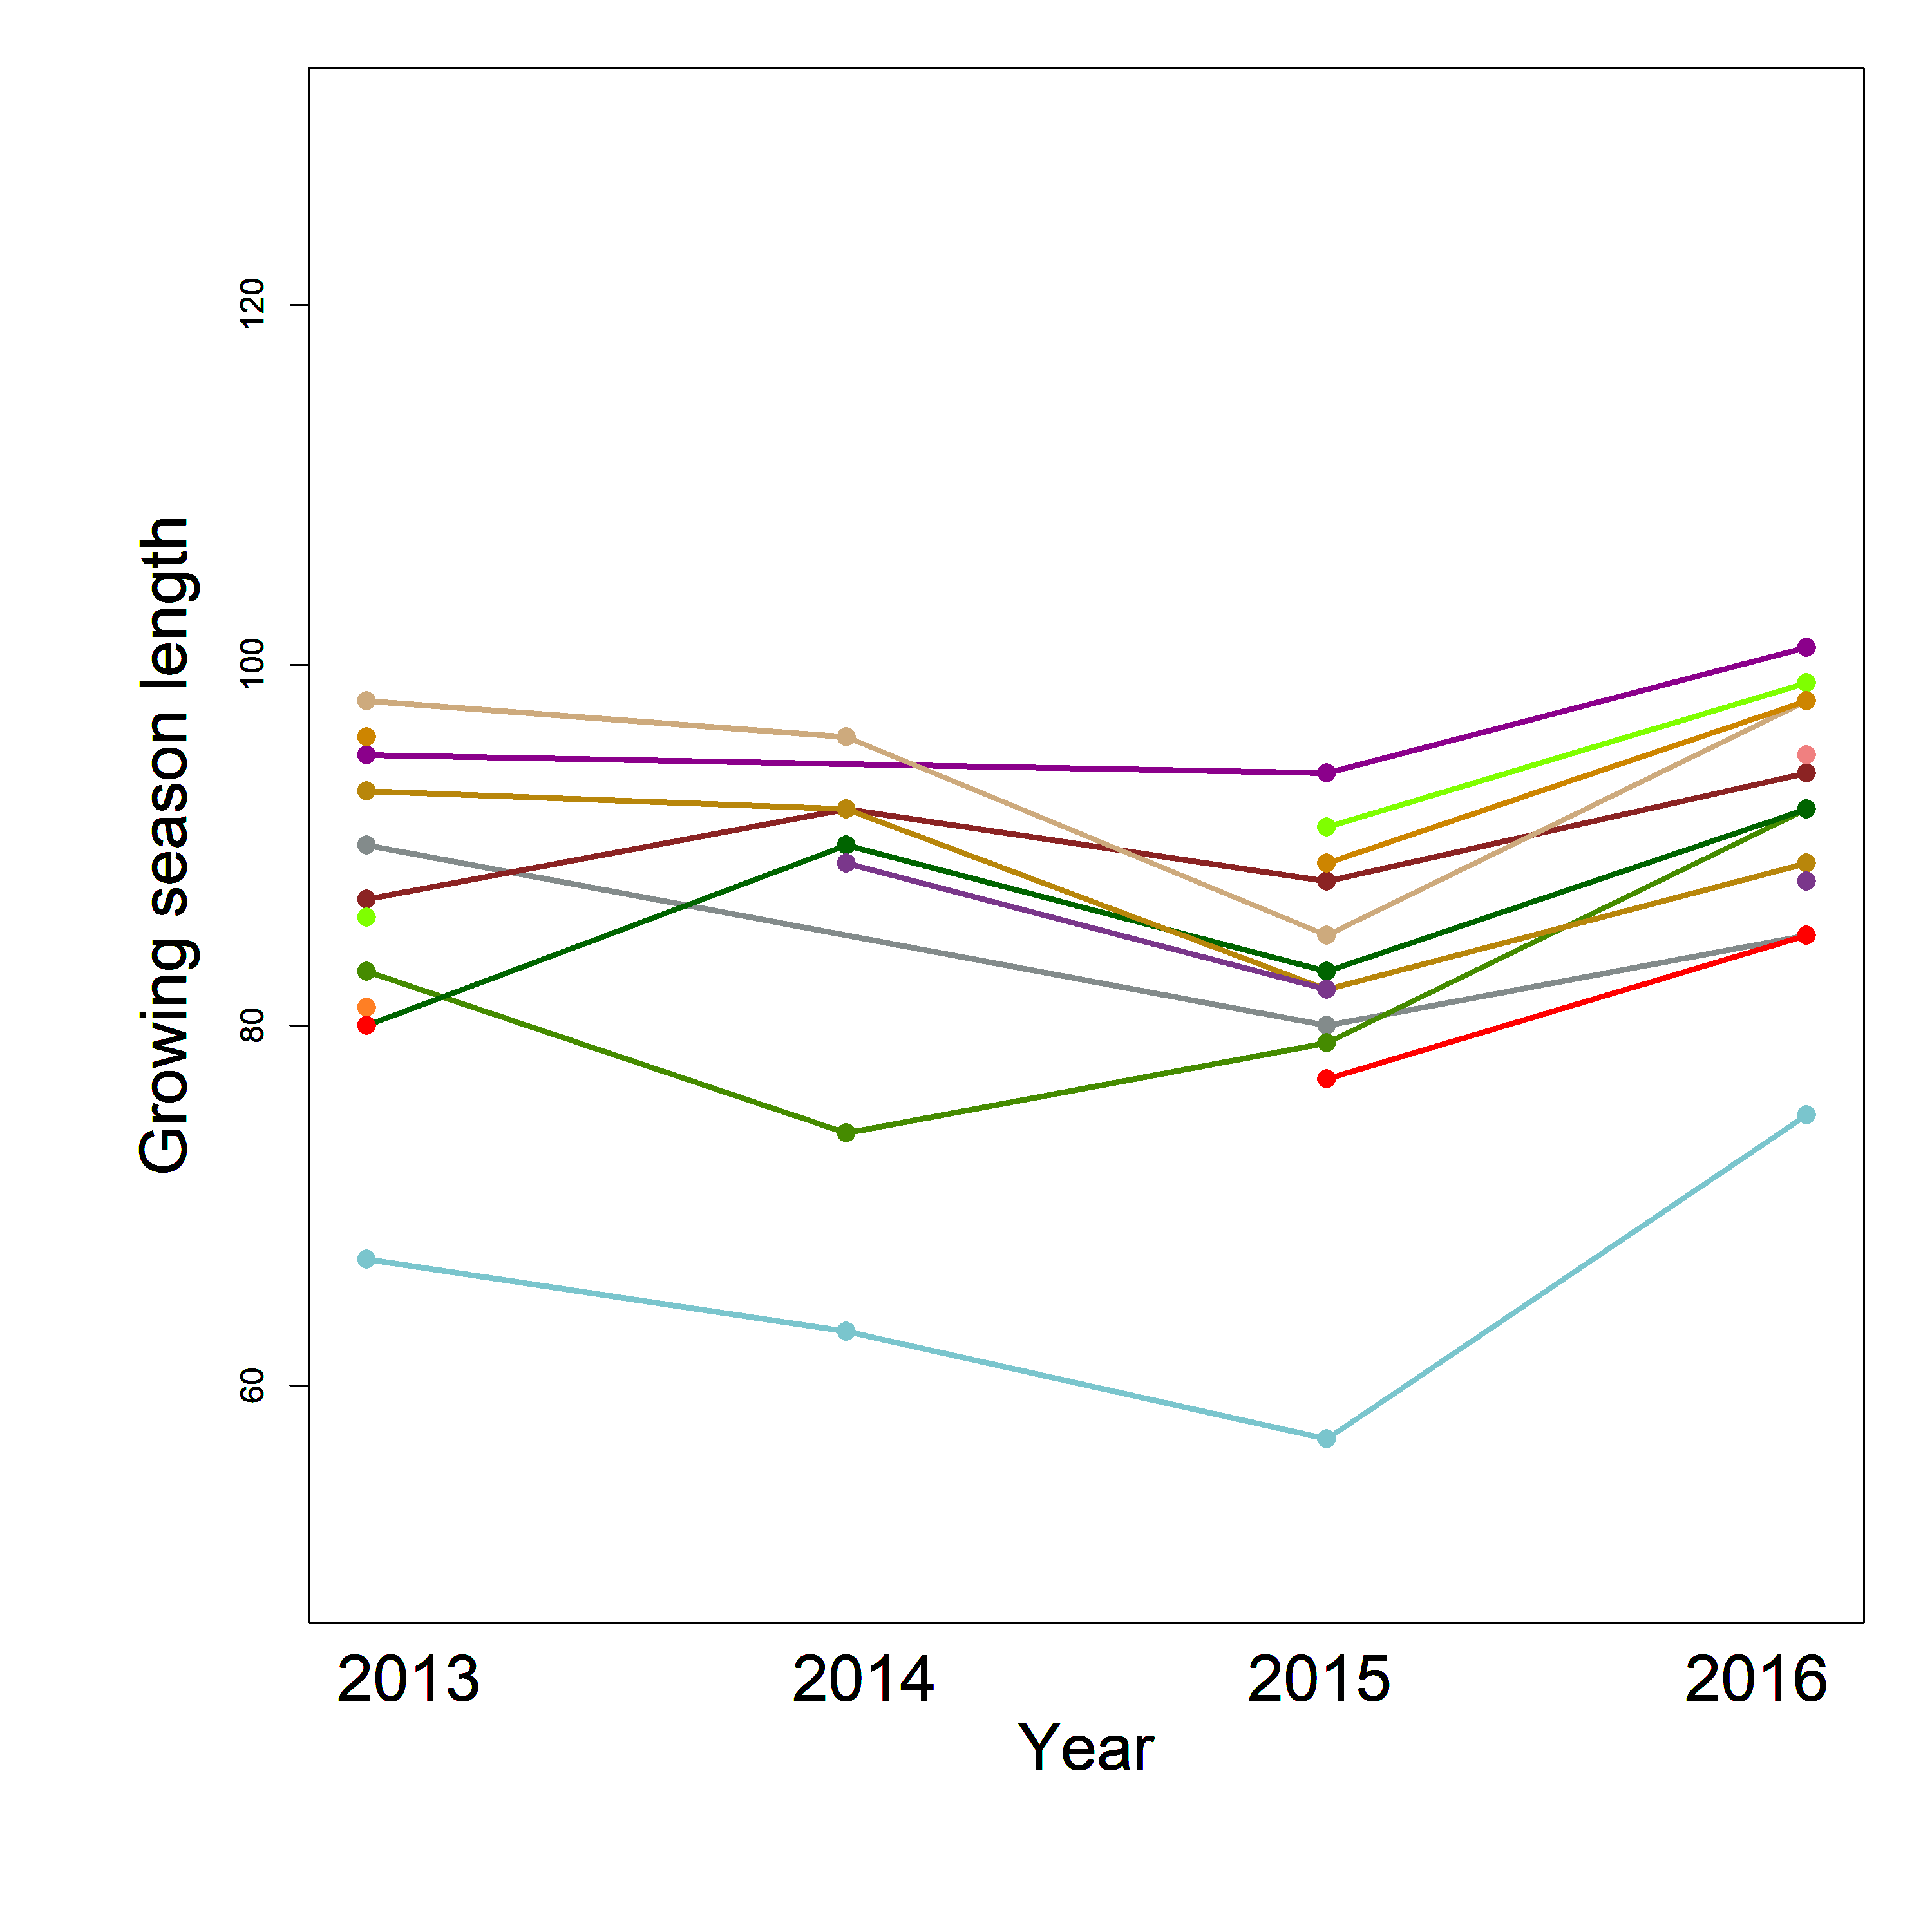
Figure 5. Interannual trend of growing season length of 1) Temperate wet meadows (SCIRBI), 2) fluvial marshes (Maskinongé), 3)Peatlands (Lac-à-la-Tortue), 4) Peatlands (Bog-à-lanières) and 5) Arctic wet meadows (Umiujaq).. Each color represents a unique plant community within each ecosystem(dots). Dots represents length of a particular community in a given year and lines represent interannual trends of the length for each community.

Hierarchical modelling implementation using lm function within R environment
Example using Green.down
Factor1<- lm(pheno_off$Green.down~ pheno_off$Ecosystem)
resFactor2<- resid(Factor1)
Factor2<-lm(resFactor2~pheno_off$Species.richness)
resFactor2<-resid(Factor2)
Factor3<- lm(resFactor2~pheno_off$Ecosystem/(pheno_off$Year))
Factor4<- lm(resFactor2~pheno_off$Ecosystem/(pheno_off$Year+pheno_off$Community.identity))
lm(resFactor2~pheno_off$Ecosystem/(pheno_off$Year+pheno_off$Community.identity + Year * Community.identity))

Ecosystem identity<- summary(Factor1)$adj.r.squared
Species richness<- ((1-Ecossytem identity)*summary(Factor2)$adj.r.squared)
Community temporal variance<- ((1 – Ecosystem identity- Species richness)*summary(Factor3)$adj.r.squared)
Community average functioning<- ((1-Ecosystem identity – Species richness)*(summary(Factor4)$adj.r.squared-summary(Factor3)$adj.r.squared))
Community asynchrony<- ((1-Ecosystem identity – Species richness)*(summary(Factor5-summary(Factor4)$adj.r.squared-summary(Factor3)$adj.r.squared))

Table 4. Complete database.
Year | Ecosystem | Community identity | Green-up | Green-down | Growing season length | Species richness | Soil pH | Soil Moisture
2013 | scirbi | 21 | 175 | 277 | 102 | 6 | NA | NA
2013 | scirbi | 23 | 183 | 273 | 90 | 6.25 | NA | NA
2013 | scirbi | 24 | 166 | 263 | 97 | 6.25 | NA | NA
2013 | scirbi | 25 | 184 | 270 | 86 | 5.75 | NA | NA
2013 | scirbi | 26 | 189 | 291 | 102 | 2.75 | NA | NA
2013 | scirbi | 27 | 171 | 262 | 91 | 5.25 | NA | NA
2013 | scirbi | 29 | 164 | 279 | 115 | 4.75 | NA | NA
2013 | scirbi | 30 | 147 | 275 | 128 | 2.25 | NA | NA
2013 | scirbi | 31 | 157 | 265 | 108 | 3.25 | NA | NA
2013 | scirbi | 32 | 148 | 265 | 117 | 4.25 | NA | NA
2013 | scirbi | 33 | 148 | 258 | 110 | 3.25 | NA | NA
2013 | scirbi | 34 | 164 | 268 | 104 | 5.5 | NA | NA
2013 | scirbi | 35 | 166 | 257 | 91 | 3.75 | NA | NA
2013 | scirbi | 36 | 155 | 260 | 105 | 1.25 | NA | NA
2013 | scirbi | 37 | 154 | 251 | 97 | 2 | NA | NA
2013 | scirbi | 38 | 153 | 283 | 130 | 1.25 | NA | NA
2013 | scirbi | 39 | 177 | 276 | 99 | 4.25 | NA | NA
2013 | scirbi | 40 | 136 | 266 | 130 | 5.5 | NA | NA
2013 | tortue | 1 | 162 | NA | NA | 5 | NA | NA
2013 | tortue | 10 | 160 | NA | NA | 5.75 | NA | NA
2013 | tortue | 11 | 160 | 250 | 90 | 10 | NA | NA
2013 | tortue | 12 | 144 | 252 | 108 | 10 | NA | NA
2013 | tortue | 13 | 151 | 255 | 104 | 7.5 | NA | NA
2013 | tortue | 15 | 159 | 253 | 94 | 7 | NA | NA
2013 | tortue | 16 | 148 | 248 | 100 | 3.25 | NA | NA
2013 | tortue | 17 | 172 | NA | NA | 5.25 | NA | NA
2013 | tortue | 18 | 146 | 269 | 123 | 4.75 | NA | NA
2013 | tortue | 19 | 141 | 252 | 111 | 7.25 | NA | NA
2013 | tortue | 2 | 151 | 272 | 121 | 6 | NA | NA
2013 | tortue | 20 | 159 | 262 | 103 | 7 | NA | NA
2013 | tortue | 4 | 162 | 260 | 98 | 3.75 | NA | NA
2013 | tortue | 5 | 152 | 273 | 121 | 3 | NA | NA
2013 | tortue | 6 | 117 | 236 | 119 | 4 | NA | NA
2013 | tortue | 7 | 147 | 253 | 106 | 4.25 | NA | NA
2013 | tortue | 9 | 149 | 253 | 104 | 4 | NA | NA
2013 | umiujaq | 61 | 163 | 258 | 95 | 1 | NA | NA
2013 | umiujaq | 62 | 162 | 248 | 86 | 1 | NA | NA
2013 | umiujaq | 63 | 165 | 255 | 90 | 3.75 | NA | NA
2013 | umiujaq | 64 | 172 | 255 | 83 | 6.5 | NA | NA
2013 | umiujaq | 65 | 168 | 249 | 81 | 5.75 | NA | NA
2013 | umiujaq | 66 | 166 | 246 | 80 | 6.5 | NA | NA
2013 | umiujaq | 67 | 163 | 256 | 93 | 4 | NA | NA
2013 | umiujaq | 70 | 166 | 262 | 96 | 5.75 | NA | NA
2013 | umiujaq | 71 | 168 | 248 | 80 | 3.5 | NA | NA
2013 | umiujaq | 72 | 167 | 254 | 87 | 4 | NA | NA
2013 | umiujaq | 73 | 166 | 264 | 98 | 2.25 | NA | NA
2013 | umiujaq | 74 | 180 | 247 | 67 | 2.25 | NA | NA
2013 | bog | 48 | 170 | NA | NA | 7.75 | NA | NA
2013 | bog | 49 | 155 | 247 | 92 | 4 | NA | NA
2013 | bog | 54 | 170 | 250 | 80 | 5.5 | NA | NA
2013 | bog | 57 | 149 | 268 | 119 | 6.75 | NA | NA
2013 | bog | 58 | 156 | 244 | 88 | 4 | NA | NA
2013 | bog | 59 | 158 | 249 | 91 | 5.5 | NA | NA
2013 | bog | 60 | 149 | 267 | 118 | 8.25 | NA | NA
2014 | scirbi | 21 | 187 | 277 | 90 | 8.75 | NA | NA
2014 | scirbi | 22 | 180 | 269 | 89 | 7 | NA | NA
2014 | scirbi | 23 | 181 | 267 | 86 | 6.5 | NA | NA
2014 | scirbi | 24 | 178 | 266 | 88 | 6 | NA | NA
2014 | scirbi | 25 | 179 | 274 | 95 | 7.5 | NA | NA
2014 | scirbi | 26 | 164 | 288 | 124 | 2.5 | NA | NA
2014 | scirbi | 27 | 184 | 271 | 87 | 4.25 | NA | NA
2014 | scirbi | 28 | 177 | 266 | 89 | 2.75 | NA | NA
2014 | scirbi | 29 | 173 | 285 | 112 | 7.5 | NA | NA
2014 | scirbi | 30 | 169 | 268 | 99 | 3.75 | NA | NA
2014 | scirbi | 31 | 169 | 270 | 101 | 2.5 | NA | NA
2014 | scirbi | 32 | 170 | 265 | 95 | 3 | NA | NA
2014 | scirbi | 33 | 166 | 260 | 94 | 2 | NA | NA
2014 | scirbi | 35 | 175 | 266 | 91 | 3.25 | NA | NA
2014 | scirbi | 36 | 183 | 282 | 99 | 3 | NA | NA
2014 | scirbi | 37 | 175 | 261 | 86 | 2.25 | NA | NA
2014 | scirbi | 38 | 170 | 277 | 107 | 1.75 | NA | NA
2014 | scirbi | 39 | 184 | 270 | 86 | 5.25 | NA | NA
2014 | scirbi | 40 | 161 | 271 | 110 | 6 | NA | NA
2014 | tortue | 1 | 146 | 258 | 112 | 5.75 | NA | NA
2014 | tortue | 10 | 145 | 260 | 115 | 6.5 | NA | NA
2014 | tortue | 11 | 149 | 256 | 107 | 8.25 | NA | NA
2014 | tortue | 12 | 137 | 254 | 117 | 10.25 | NA | NA
2014 | tortue | 13 | 147 | 250 | 103 | 7 | NA | NA
2014 | tortue | 14 | 143 | 262 | 119 | 5 | NA | NA
2014 | tortue | 15 | 154 | 277 | 123 | 7 | NA | NA
2014 | tortue | 16 | 119 | 223 | 104 | 4.5 | NA | NA
2014 | tortue | 17 | 153 | 252 | 99 | 5.75 | NA | NA
2014 | tortue | 18 | 147 | 267 | 120 | 7 | NA | NA
2014 | tortue | 19 | 145 | 246 | 101 | 6.5 | NA | NA
2014 | tortue | 2 | 143 | 263 | 120 | 5.5 | NA | NA
2014 | tortue | 20 | 147 | 270 | 123 | 7.75 | NA | NA
2014 | tortue | 4 | 137 | 265 | 128 | 4 | NA | NA
2014 | tortue | 5 | 145 | 263 | 118 | 4 | NA | NA
2014 | tortue | 6 | 140 | 263 | 123 | 4.5 | NA | NA
2014 | tortue | 7 | 140 | 260 | 120 | 4.25 | NA | NA
2014 | tortue | 8 | 151 | 259 | 108 | 5 | NA | NA
2014 | tortue | 9 | 145 | 253 | 108 | 4.5 | NA | NA
2014 | bog | 41 | 156 | 252 | 96 | 6 | NA | NA
2014 | bog | 42 | 160 | 252 | 92 | 7 | NA | NA
2014 | bog | 43 | 155 | 252 | 97 | 7 | NA | NA
2014 | bog | 44 | 147 | 264 | 117 | 7 | NA | NA
2014 | bog | 45 | 153 | 246 | 93 | 4.75 | NA | NA
2014 | bog | 46 | 150 | NA | NA | 8.75 | NA | NA
2014 | bog | 48 | 147 | 249 | 102 | 6.25 | NA | NA
2014 | bog | 49 | 158 | 241 | 83 | 4 | NA | NA
2014 | bog | 50 | 142 | 259 | 117 | 7.25 | NA | NA
2014 | bog | 51 | 155 | 255 | 100 | 8.75 | NA | NA
2014 | bog | 52 | 150 | 261 | 111 | 7 | NA | NA
2014 | bog | 53 | 156 | NA | NA | 10.5 | NA | NA
2014 | bog | 54 | 155 | 247 | 92 | 3 | NA | NA
2014 | bog | 555 | 166 | 266 | 100 | 8.75 | NA | NA
2014 | bog | 556 | 158 | 267 | 109 | 5 | NA | NA
2014 | bog | 57 | 150 | 258 | 108 | 7.25 | NA | NA
2014 | bog | 58 | 149 | 245 | 96 | 5 | NA | NA
2014 | bog | 59 | 160 | 246 | 86 | 4.25 | NA | NA
2014 | bog | 60 | 143 | 261 | 118 | 6.75 | NA | NA
2014 | umiujaq | 62 | 160 | NA | NA | 1 | NA | NA
2014 | umiujaq | 64 | 173 | 247 | 74 | 7 | NA | NA
2014 | umiujaq | 65 | 164 | NA | NA | 6 | NA | NA
2014 | umiujaq | 66 | 162 | 252 | 90 | 7 | NA | NA
2014 | umiujaq | 67 | 162 | 254 | 92 | 5 | NA | NA
2014 | umiujaq | 68 | 163 | 252 | 89 | 5 | NA | NA
2014 | umiujaq | 69 | 165 | 254 | 89 | 5 | NA | NA
2014 | umiujaq | 70 | 164 | NA | NA | 5.75 | NA | NA
2014 | umiujaq | 71 | 163 | NA | NA | 3.5 | NA | NA
2014 | umiujaq | 72 | 162 | 254 | 92 | 4.66666666666667 | NA | NA
2014 | umiujaq | 73 | 163 | 259 | 96 | 2 | NA | NA
2014 | umiujaq | 74 | 180 | 243 | 63 | 3.66666666666667 | NA | NA
2015 | scirbi | 21 | 141 | 265 | 124 | 9.75 | 5.78 | 46.575
2015 | scirbi | 22 | 141 | 255 | 114 | 9.25 | 4.97 | 53.9
2015 | scirbi | 23 | 143 | 242 | 99 | 6 | 5.51 | 50.1
2015 | scirbi | 24 | 142 | 247 | 105 | 8 | 5.345 | 55.65
2015 | scirbi | 25 | 145 | 259 | 114 | 6.75 | 5.955 | 45.425
2015 | scirbi | 26 | 136 | 273 | 137 | 3.25 | 5.69 | 22.55
2015 | scirbi | 27 | 151 | 242 | 91 | 6 | 5.295 | 55.3
2015 | scirbi | 28 | 140 | 259 | 119 | 2.75 | 5.715 | 35.475
2015 | scirbi | 29 | 141 | 271 | 130 | 7.5 | 5.435 | 22.35
2015 | scirbi | 30 | 136 | 273 | 137 | 3.5 | 5.335 | 22.675
2015 | scirbi | 31 | 138 | 268 | 130 | 2.75 | 5.26 | 27.725
2015 | scirbi | 32 | 140 | 252 | 112 | 3.75 | 5.415 | 21.625
2015 | scirbi | 33 | 140 | 251 | 111 | 2.25 | 5.75 | 14.225
2015 | scirbi | 34 | 150 | 250 | 100 | 10.25 | 5.19 | 38.575
2015 | scirbi | 35 | 151 | 248 | 97 | 3.25 | 5.1 | 52.575
2015 | scirbi | 36 | 134 | 282 | 148 | 2.5 | 5.645 | 43.75
2015 | scirbi | 37 | 137 | 249 | 112 | 2.75 | 5.755 | 36.975
2015 | scirbi | 38 | 134 | 271 | 137 | 3 | 5.72 | 34.575
2015 | scirbi | 39 | 153 | 253 | 100 | 6.25 | 5.255 | 51.325
2015 | scirbi | 40 | 148 | 269 | 121 | 7.5 | 5.475 | 57.05
2015 | tortue | 1 | 144 | 258 | 114 | 4.5 | 3.4975 | 88.3
2015 | tortue | 10 | 137 | 270 | 133 | 6 | 3.405 | 58.075
2015 | tortue | 11 | 150 | 267 | 117 | 9.25 | 3.845 | 80.075
2015 | tortue | 12 | 130 | 270 | 140 | 10 | 3.3925 | 70.575
2015 | tortue | 14 | 142 | 272 | 130 | 5 | 3.615 | 83.8
2015 | tortue | 15 | 144 | 277 | 133 | 7 | 3.3775 | 77.875
2015 | tortue | 16 | 147 | 259 | 112 | 3.5 | 3.465 | 82.5
2015 | tortue | 17 | 135 | 274 | 139 | 7.25 | 3.4425 | 77.125
2015 | tortue | 18 | 147 | 278 | 131 | 5 | 3.4375 | 66.225
2015 | tortue | 19 | 138 | 262 | 124 | 5.75 | 3.6325 | 83.25
2015 | tortue | 2 | 137 | 272 | 135 | 7 | 3.4675 | 86.65
2015 | tortue | 20 | 147 | 280 | 133 | 9.25 | 3.45 | 67.225
2015 | tortue | 3 | 148 | 264 | 116 | 1 | 3.41 | 87.775
2015 | tortue | 4 | 145 | 278 | 133 | 4 | 3.41 | 86
2015 | tortue | 5 | 139 | 280 | 141 | 4.5 | 3.49 | 83.15
2015 | tortue | 6 | 139 | 280 | 141 | 4 | 3.4125 | 45.8
2015 | tortue | 7 | 145 | 271 | 126 | 4 | 3.41 | 86
2015 | tortue | 8 | 152 | 275 | 123 | 5.5 | 3.4125 | 74.725
2015 | tortue | 9 | 148 | 258 | 110 | 4 | 3.355 | 85.3
2015 | bog | 41 | 160 | 253 | 93 | 7.5 | 3.995 | 72.825
2015 | bog | 42 | 163 | 266 | 103 | 6 | 3.9475 | 37.225
2015 | bog | 43 | 159 | 258 | 99 | 5.75 | 3.9225 | 59.45
2015 | bog | 45 | 148 | 254 | 106 | 3.25 | 4.26 | 77.35
2015 | bog | 46 | 154 | 252 | 98 | 8.25 | 4.25 | 63.225
2015 | bog | 48 | 157 | 262 | 105 | 5.75 | 4.0375 | 56.125
2015 | bog | 49 | 156 | 242 | 86 | 7 | 4.0975 | 73.075
2015 | bog | 50 | 161 | 249 | 88 | 8.25 | 3.9975 | 66.125
2015 | bog | 51 | 161 | 262 | 101 | 9.75 | 3.97 | 65.35
2015 | bog | 52 | 161 | 266 | 105 | 5.75 | 3.935 | 50.825
2015 | bog | 53 | 165 | 264 | 99 | 9 | 3.9775 | 37.6
2015 | bog | 54 | 152 | 254 | 102 | 4 | 4.115 | 72.2
2015 | bog | 55 | 158 | NA | NA | 4 | 3.9325 | 67.3
2015 | bog | 56 | 158 | 254 | 96 | 8.75 | 4.16 | 51.6
2015 | bog | 57 | 153 | 264 | 111 | 9 | 3.8325 | 63.075
2015 | bog | 58 | 157 | 255 | 98 | 5 | 3.8825 | 71.25
2015 | bog | 59 | 163 | 257 | 94 | 5.25 | 3.9725 | 62.6
2015 | bog | 60 | 151 | 267 | 116 | 8 | 3.9975 | 65.075
2015 | bog | 89 | 156 | 266 | 110 | 7.5 | NA | NA
2015 | umiujaq | 61 | 169 | 263 | 94 | 1 | 5 | 21.725
2015 | umiujaq | 62 | 173 | 264 | 91 | 1 | 4.92 | 18.575
2015 | umiujaq | 63 | 179 | 259 | 80 | 3.75 | 4.7 | 72.95
2015 | umiujaq | 64 | 181 | 260 | 79 | 5.5 | 5.34 | 78.175
2015 | umiujaq | 65 | 178 | NA | NA | 4.25 | 4.68 | 51.45
2015 | umiujaq | 66 | 177 | 260 | 83 | 5.75 | 5.55 | 52
2015 | umiujaq | 67 | 179 | 261 | 82 | 5.75 | 5.21 | 35.65
2015 | umiujaq | 68 | 178 | 260 | 82 | 5 | 5.62 | 46.175
2015 | umiujaq | 69 | 180 | 262 | 82 | 5 | 5.71 | 50.9
2015 | umiujaq | 70 | 176 | 265 | 89 | 6 | 4.67 | 50.175
2015 | umiujaq | 71 | 180 | 257 | 77 | 5 | 5.86 | 48.075
2015 | umiujaq | 72 | 173 | 261 | 88 | 4 | 5.38 | 47.125
2015 | umiujaq | 73 | 179 | 264 | 85 | 2 | 5.03 | 43.7
2015 | umiujaq | 74 | 188 | 245 | 57 | 2.25 | 5.18 | 86.6
2015 | umiujaq | 79 | 188 | 258 | 70 | 2.5 | 5.77 | 75.075
2015 | umiujaq | 81 | 175 | 258 | 83 | 6.5 | 6 | 40.6
2015 | umiujaq | 82 | 171 | 262 | 91 | 2.5 | 5.32 | 25.275
2015 | umiujaq | 83 | 179 | 263 | 84 | 2.25 | 5.45 | 40.025
2015 | umiujaq | 85 | 183 | 261 | 78 | 4.25 | 5.7 | 79.625
2015 | umiujaq | 86 | 181 | 259 | 78 | 6.5 | 4.89 | 73.075
2015 | umiujaq | 87 | 186 | 258 | 72 | 3.5 | 5.59 | 78.775
2015 | umiujaq | 88 | 178 | 263 | 85 | 3 | 5.52 | 79.5
2016 | scirbi | 21 | 166 | 271 | 105 | 10.25 | NA | NA
2016 | scirbi | 22 | 161 | 271 | 110 | 10.5 | NA | NA
2016 | scirbi | 24 | 170 | 260 | 90 | 7 | NA | NA
2016 | scirbi | 25 | 170 | 267 | 97 | 9.5 | NA | NA
2016 | scirbi | 26 | 162 | 284 | 122 | 3.75 | NA | NA
2016 | scirbi | 27 | 174 | 258 | 84 | 6 | NA | NA
2016 | scirbi | 28 | 164 | NA | NA | 3.75 | NA | NA
2016 | scirbi | 29 | 159 | 278 | 119 | 5.5 | NA | NA
2016 | scirbi | 30 | 155 | 270 | 115 | 5 | NA | NA
2016 | scirbi | 31 | 156 | 265 | 109 | 2.25 | NA | NA
2016 | scirbi | 32 | 157 | 259 | 102 | 4.25 | NA | NA
2016 | scirbi | 33 | 155 | 259 | 104 | 3 | NA | NA
2016 | scirbi | 34 | 158 | 258 | 100 | 9.5 | NA | NA
2016 | scirbi | 35 | 165 | 246 | 81 | 3.5 | NA | NA
2016 | scirbi | 36 | 159 | 278 | 119 | 3.5 | NA | NA
2016 | scirbi | 37 | 157 | 252 | 95 | 3.5 | NA | NA
2016 | scirbi | 38 | 157 | 273 | 116 | 3.5 | NA | NA
2016 | scirbi | 39 | 164 | 261 | 97 | 3.75 | NA | NA
2016 | scirbi | 40 | 158 | 266 | 108 | 6.5 | NA | NA
2016 | tortue | 1 | 155 | NA | NA | 6.25 | NA | NA
2016 | tortue | 10 | 157 | 263 | 106 | 7.75 | NA | NA
2016 | tortue | 11 | 154 | 261 | 107 | 9.25 | NA | NA
2016 | tortue | 12 | 153 | 261 | 108 | 9.25 | NA | NA
2016 | tortue | 13 | 151 | 259 | 108 | 7.75 | NA | NA
2016 | tortue | 14 | 150 | NA | NA | 6 | NA | NA
2016 | tortue | 16 | 152 | 260 | 108 | 4 | NA | NA
2016 | tortue | 17 | 145 | 274 | 129 | 7.5 | NA | NA
2016 | tortue | 18 | 155 | 278 | 123 | 6 | NA | NA
2016 | tortue | 2 | 149 | NA | NA | 5 | NA | NA
2016 | tortue | 20 | 155 | 276 | 121 | 7 | NA | NA
2016 | tortue | 4 | 139 | 271 | 132 | 5 | NA | NA
2016 | tortue | 5 | 155 | 275 | 120 | 5 | NA | NA
2016 | tortue | 6 | 154 | 271 | 117 | 4 | NA | NA
2016 | tortue | 7 | 147 | 262 | 115 | 5 | NA | NA
2016 | tortue | 8 | 150 | 273 | 123 | 5 | NA | NA
2016 | tortue | 9 | 150 | 255 | 105 | 5 | NA | NA
2016 | bog | 41 | 161 | 253 | 92 | 7.75 | NA | NA
2016 | bog | 42 | 166 | 265 | 99 | 8 | NA | NA
2016 | bog | 47 | 153 | 257 | 104 | 9.75 | NA | NA
2016 | bog | 48 | 164 | 264 | 100 | 7.5 | NA | NA
2016 | bog | 49 | 163 | 250 | 87 | 6 | NA | NA
2016 | bog | 50 | 153 | 264 | 111 | 10.75 | NA | NA
2016 | bog | 52 | 172 | 263 | 91 | 6.5 | NA | NA
2016 | bog | 54 | 161 | NA | NA | 5.75 | NA | NA
2016 | bog | 55 | 168 | 242 | 74 | 5.5 | NA | NA
2016 | bog | 57 | 166 | 265 | 99 | 5 | NA | NA
2016 | bog | 59 | 171 | 253 | 82 | 5 | NA | NA
2016 | bog | 60 | 157 | 264 | 107 | 7.25 | NA | NA
2016 | umiujaq | 61 | 167 | 268 | 101 | 1 | NA | NA
2016 | umiujaq | 62 | 166 | 265 | 99 | 1 | NA | NA
2016 | umiujaq | 63 | 170 | 255 | 85 | 3 | NA | NA
2016 | umiujaq | 64 | 169 | 261 | 92 | 5.5 | NA | NA
2016 | umiujaq | 65 | 170 | 262 | 92 | 7.5 | NA | NA
2016 | umiujaq | 66 | 168 | 260 | 92 | 6.25 | NA | NA
2016 | umiujaq | 67 | 169 | 258 | 89 | 6 | NA | NA
2016 | umiujaq | 68 | 166 | 261 | 95 | 4.25 | NA | NA
2016 | umiujaq | 69 | 172 | 260 | 88 | 4.5 | NA | NA
2016 | umiujaq | 70 | 172 | 270 | 98 | 6.25 | NA | NA
2016 | umiujaq | 71 | 172 | 257 | 85 | 4.75 | NA | NA
2016 | umiujaq | 72 | 168 | 262 | 94 | 4.5 | NA | NA
2016 | umiujaq | 73 | 171 | 269 | 98 | 2.25 | NA | NA
2016 | umiujaq | 74 | 172 | 247 | 75 | 3.5 | NA | NA
2016 | umiujaq | 76 | 185 | 259 | 74 | 2.5 | NA | NA
2016 | umiujaq | 77 | 172 | NA | NA | 7.75 | NA | NA
2016 | umiujaq | 78 | 175 | 255 | 80 | 6.75 | NA | NA
2016 | umiujaq | 79 | 182 | 255 | 73 | 3.75 | NA | NA
2016 | umiujaq | 83 | 171 | NA | NA | 0 | NA | NA
2016 | umiujaq | 84 | 171 | 252 | 81 | 3.75 | NA | NA
2016 | umiujaq | 85 | 178 | 258 | 80 | 4.75 | NA | NA
2016 | umiujaq | 86 | 173 | 258 | 85 | 7 | NA | NA
2016 | umiujaq | 87 | 179 | 252 | 73 | 4.25 | NA | NA
2016 | umiujaq | 88 | 172 | NA | NA | 1.75 | NA | NA
2016 | maski | 106 | 169 | 282 | 113 | 1.75 | NA | NA
2016 | maski | 107 | 161 | 273 | 112 | 5.75 | NA | NA
2016 | maski | 120 | 155 | 274 | 119 | 4.25 | NA | NA
2016 | maski | 121 | 146 | 261 | 115 | 3.5 | NA | NA
2016 | maski | 122 | 156 | 269 | 113 | 3 | NA | NA
2016 | maski | 123 | 148 | 275 | 127 | 4.25 | NA | NA
2016 | maski | 124 | 157 | 261 | 104 | 5 | NA | NA
2016 | maski | 125 | 152 | 276 | 124 | 5 | NA | NA
2016 | maski | 126 | 158 | 281 | 123 | 2.25 | NA | NA
2016 | maski | 127 | 151 | 244 | 86 | 2.5 | NA | NA
2016 | maski | 200 | 166 | 290 | 124 | 2.25 | NA | NA
2016 | maski | 201 | 170 | 320 | 150 | 1.75 | NA | NA
2016 | maski | 202 | 167 | 282 | 115 | 3.25 | NA | NA
2016 | maski | 203 | 166 | 279 | 113 | 7.25 | NA | NA
2016 | maski | 204 | 181 | 276 | 95 | 3.5 | NA | NA
2016 | maski | 205 | 172 | 273 | 101 | 5.25 | NA | NA
2016 | maski | 207 | 172 | 326 | 154 | 3.25 | NA | NA
2016 | maski | 208 | 168 | 260 | 92 | 6.25 | NA | NA
2016 | maski | 209 | 174 | 263 | 89 | 6.5 | NA | NA
2016 | maski | 210 | 170 | 274 | 104 | 8.75 | NA | NA
2016 | maski | 211 | 162 | 274 | 112 | 6 | NA | NA
2016 | maski | 212 | 165 | 272 | 107 | 5.25 | NA | NA
2016 | maski | 213 | 170 | 272 | 102 | 5.5 | NA | NA
2016 | maski | 214 | 170 | 271 | 101 | 5.75 | NA | NA
2016 | maski | 215 | 161 | 272 | 111 | 4.25 | NA | NA
2016 | maski | 216 | 173 | 291 | 118 | 2.5 | NA | NA
2016 | maski | 217 | 161 | 268 | 107 | 3.75 | NA | NA
2016 | maski | 218 | 165 | 256 | 91 | 3.25 | NA | NA
2016 | maski | 219 | 161 | 263 | 102 | 3.5 | NA | NA
2016 | maski | 220 | 157 | 269 | 112 | 6.5 | NA | NA
2016 | maski | 221 | 169 | 297 | 128 | 1 | NA | NA
2013 | tortue | 14 | NA | 261 | NA | 4.75 | NA | NA
2013 | bog | 47 | NA | 252 | NA | 8.5 | NA | NA
2013 | bog | 50 | NA | 269 | NA | 7.5 | NA | NA
2014 | scirbi | 34 | NA | 260 | NA | 8.5 | NA | NA
2014 | bog | 47 | NA | 262 | NA | 8 | NA | NA
2014 | umiujaq | 61 | NA | 265 | NA | 1 | NA | NA
2014 | umiujaq | 63 | NA | 258 | NA | 3.75 | NA | NA
2015 | bog | 47 | NA | 259 | NA | 7.25 | 3.9675 | 45.075
2015 | umiujaq | 75 | NA | 255 | NA | 5.5 | 5.65 | 66.075
2015 | umiujaq | 76 | NA | 258 | NA | 3 | 5.29 | 85.25
2015 | umiujaq | 77 | NA | 261 | NA | 7.5 | 5.97 | 67.575
2015 | umiujaq | 78 | NA | 257 | NA | 6.5 | 5.8 | 67.25
2015 | umiujaq | 80 | NA | 261 | NA | 6.5 | 5.66 | 51.7
2015 | umiujaq | 84 | NA | 266 | NA | 3.5 | 5.5 | 73.8
2015 | maski | 120 | NA | 275 | NA | 4.66666666666667 | 6.41 | 45.375
2015 | maski | 121 | NA | 268 | NA | 3 | 6.405 | 37.225
2015 | maski | 123 | NA | 273 | NA | 3.66666666666667 | 6.62 | 56.225
2015 | maski | 124 | NA | 262 | NA | 4.33333333333333 | 6.52 | 57.575
2015 | maski | 125 | NA | 251 | NA | 4 | 6.225 | 52.2
2015 | maski | 126 | NA | 268 | NA | 2.33333333333333 | 6.09 | 42.375
2015 | maski | 201 | NA | 259 | NA | 1.33333333333333 | 5.865 | 85.5
2015 | maski | 202 | NA | 270 | NA | 2.66666666666667 | 5.895 | 86.65
2015 | maski | 203 | NA | 261 | NA | 8.66666666666667 | 6.13 | 61.225
2015 | maski | 205 | NA | 248 | NA | 6.33333333333333 | 6.185 | 52.95
2015 | maski | 207 | NA | 256 | NA | 2 | 6.09 | 61.525
2015 | maski | 208 | NA | 259 | NA | 7.33333333333333 | 6.045 | 62.5
2015 | maski | 209 | NA | 253 | NA | 4 | 6.235 | 57.675
2015 | maski | 210 | NA | 260 | NA | 11.3333333333333 | 6.22 | 59.225
2015 | maski | 211 | NA | 255 | NA | 6.33333333333333 | 6.36 | 61.5
2015 | maski | 212 | NA | 258 | NA | 5 | 6.61 | 61.925
2015 | maski | 213 | NA | 250 | NA | 3.66666666666667 | 6.46 | 37.7
2015 | maski | 214 | NA | 260 | NA | 6.33333333333333 | 6.665 | 56
2015 | maski | 215 | NA | 276 | NA | 5.66666666666667 | 6.32 | 16.9
2015 | maski | 216 | NA | 267 | NA | 1.66666666666667 | 6.515 | 24.625
2015 | maski | 219 | NA | 258 | NA | 3.33333333333333 | 7.005 | 42.725
2015 | maski | 220 | NA | 256 | NA | 6.66666666666667 | 6.815 | 54.75
2016 | scirbi | 23 | NA | 263 | NA | 9 | NA | NA
2016 | tortue | 15 | NA | 274 | NA | 4.5 | NA | NA
2015 | tortue | 13 | NA | NA | NA | 5.75 | 3.485 | 83.925
2015 | bog | 44 | NA | NA | NA | 6.75 | 3.9625 | 33.85
2015 | maski | 106 | NA | NA | NA | 1.33333333333333 | 6.62 | 50.475
2015 | maski | 107 | NA | NA | NA | 5.33333333333333 | 6.78 | 57.6
2015 | maski | 122 | NA | NA | NA | 4 | 6.395 | 62.775
2015 | maski | 127 | NA | NA | NA | 1.66666666666667 | 6.465 | 59.2
2015 | maski | 200 | NA | NA | NA | 7 | 5.985 | 89.05
2015 | maski | 204 | NA | NA | NA | 2.66666666666667 | 6.47 | 40.725
2015 | maski | 217 | NA | NA | NA | 3.33333333333333 | 6.555 | 45.525
2015 | maski | 218 | NA | NA | NA | 3 | 6.055 | 59.35
2015 | maski | 221 | NA | NA | NA | 1 | 6.025 | 51.375
2014 | tortue | 3 | NA | NA | NA | 1 | NA | NA
2013 | tortue | 3 | NA | NA | NA | 1 | NA | NA
2013 | bog | 53 | NA | NA | NA | 3.75 | NA | NA
2013 | bog | 56 | NA | NA | NA | 2.75 | NA | NA
2013 | umiujaq | 68 | NA | NA | NA | 5.5 | NA | NA
2013 | umiujaq | 69 | NA | NA | NA | 4.75 | NA | NA

